CM2020: Agile Software Projects

Final Report

“To-Do Application”
A productivity app to help people with planning and accomplishing their tasks

TEAM 82

Authors:
Akhila Rao Sambangi (220628334)
Seah Zhao Xiang (220628884)
Seenivasan Siva Ranjana (220516178)
Nisha Ramprasath (220631895)
Ramu Kirubanidhi (210469394)

Table of Contents
Table of Contents 1
Abstract 3
Outcomes 3
Introduction 3
Planning and Research 4
Front-end 4
Back-end 6
Computational resources 6
Breakdown of the team 8
Time and Resources allocation 9
Gantt Chart 10
Design and Development 10
Design Specifications 10
Testing 10
White box testing 10
Test environment 10
Test cases 11
Test execution and results 11
Design Iteration - first iteration 12
Overall - second iteration 17
Heuristic Evaluation 21
1. Visibility of System Status: 21
2. Match Between System and the Real World: 21
3. User Control and Freedom: 21
4. Consistency and Standards: 21
5. Error Prevention: 21
6. Recognition Rather Than Recall: 22
7. Flexibility and Efficiency of Use: 22
8. Aesthetic and Minimalist Design: 22
9. Help Users Recognize, Diagnose, and Recover from Errors: 22
10. Help and Documentation: 22
Initial Design 22
Production prototype, first iteration 22
Secondary Design 25
Three Tier Architecture 28
Presentation Tier 28
Application Tier 28
Data Tier 28
Structure and Implementation 29
Components of the software 29
User Interface(UI) 29
Application components 29
Database components 30
API components 30
Testing components 31
Modules needed 31
Libraries used 31
Express.js 31
Node.js 33
SQLite 34
TailwindCSS 35
Bcrypt 36
Mocha 37
Chai 38
Supertest 39
Evaluation 40
Back-end 40
Conceptual Issues 40
Technical Issues 40
Front-end 41
Conceptual Issues 41
Technical Issues 41
Conclusion 42
Future Development 42
Colour Blindness 43
Agile in practice 44
Conclusion 44
References 45
Appendices 47
Appendix A: 47
Appendix B: 53

Abstract
Our project focuses on developing an innovative task management application designed to streamline productivity and improve organisational efficiency for users. The application is built with a user-centric approach, offering a robust set of features aimed at helping users manage their tasks effectively, maintain order, and achieve their goals with greater ease. Key functionalities include a user-friendly interface, secure password management enhanced by tokenization, and the ability to edit, delete, and prioritise tasks. Additionally, the application supports collaborative work by allowing users to share task links and engage with a community page where they can share task completions and images, and receive likes from others.

Outcomes
The primary outcome of our project is to provide users with a reliable and efficient tool that simplifies task management while enhancing productivity. Users can expect a safe and personalised experience, complete with features like username creation, password resets, and user registration. The app includes a task progress bar that visually represents the completion status of tasks, and prioritisation flags to help users organise their work effectively. Additional features such as the ability to annotate tasks with notes and share task URLs for collaboration further enhance the user experience. The community page fosters interaction among users, allowing them to share achievements and gain recognition. Overall, the application is designed to be accessible and intuitive, catering to users of all skill levels.

Introduction
The primary outcome of our project is to provide users with a reliable and efficient tool that simplifies task management while enhancing productivity. Users can expect a safe and personalised experience, complete with features like username creation, password resets, and user registration. The app includes a task progress bar that visually represents the completion status of tasks, and prioritisation flags to help users organise their work effectively. Additional features such as the ability to annotate tasks with notes and share task URLs for collaboration further enhance the user experience. The community page fosters interaction among users, allowing them to share achievements and gain recognition. Overall, the application is designed to be accessible and intuitive, catering to users of all skill levels.

Planning and Research

Front-end
During the development of our project, we followed a structured approach to build the application’s functionality and design. Our process involved several key steps, starting with creating core functions, adding common CSS for basic styling, and eventually integrating Tailwind CSS for a more robust and flexible design system. Additionally, we carefully selected our backend technologies to ensure a seamless and efficient application. Below is an overview of each step in our development process:

1. Creating Core Functions
The first step in our development process was to create the core functions that form the backbone of our application. This involved developing essential features such as user authentication, task management, and data processing.
- User Authentication:
We implemented functions to handle user registration and login, utilising bcrypt for password hashing to ensure secure storage of user credentials. This was a critical step in establishing a secure foundation for our application and protecting sensitive user information.
- Task Management:
Functions were developed to manage tasks, allowing users to create, edit, delete, and view tasks. These functions interacted with our SQLite database, enabling efficient data storage and retrieval, which is crucial for maintaining a smooth user experience.
- Data Processing:
Additional functions were created to handle data input and output, ensuring smooth interaction between the frontend and backend. This included functions for form handling, data validation, and API requests. These functions were essential for ensuring that our application was robust and could handle various user interactions effectively.
By focusing on these core functionalities first, we ensured that the application was functional and met our basic requirements before moving on to design and aesthetics.

2. Adding Common CSS
Once the core functionality was in place, we turned our attention to the application's visual presentation. Initially, we added common CSS to provide basic styling and ensure a consistent look and feel across the application.
- Basic Layout and Styling:
We created a simple, clean layout using common CSS techniques. This included defining the overall structure of pages, such as headers, footers, navigation bars, and content sections. Establishing a basic layout early on allowed us to ensure a consistent structure across different parts of the application.
- Typography and Colors:
Basic typography styles and colour schemes were applied to make the content readable and visually appealing. We chose a neutral colour palette to provide a clean and professional appearance, ensuring the focus remained on the content without overwhelming the user.
- Responsive Design:
Basic responsive design principles were applied to ensure that the application was accessible on various devices. This involved using CSS media queries to adjust the layout for different screen sizes, ensuring a good user experience across desktops, tablets, and mobile devices.
Adding common CSS allowed us to establish a foundational style for our application, making it presentable and user-friendly before introducing more advanced styling techniques.

3. Integrating Tailwind CSS
After establishing a basic style with common CSS, we decided to enhance our design using Tailwind CSS, a utility-first CSS framework that offers greater flexibility and efficiency.
- Utility-First Approach:
Tailwind CSS provides a utility-first approach to styling, allowing us to apply styles directly within HTML elements using predefined classes. This approach significantly reduced the need for custom CSS, making our codebase cleaner and more maintainable.
- Customization and Flexibility:
Tailwind CSS is highly customizable, enabling us to easily modify default settings such as colours, spacing, typography, and breakpoints. This flexibility allowed us to quickly adapt the design to match our desired aesthetic without writing extensive custom CSS.
- Consistent and Modern Design:
By integrating Tailwind CSS, we were able to create a consistent and modern design across the entire application. The framework's utility classes made it easy to implement responsive design patterns and apply consistent spacing and typography throughout the application.
- Efficiency in Development:
Tailwind CSS streamlined our development process by providing ready-to-use utility classes, reducing the time required to write custom CSS. This efficiency allowed us to focus more on building functionality and improving user experience.
By transitioning from common CSS to Tailwind CSS, we enhanced our application's design, making it more visually appealing and easier to maintain. The integration of Tailwind CSS marked the final step in our development process, resulting in a functional, secure, and aesthetically pleasing application.

Back-end
For the backend development of our application, we chose a combination of Node.js, Express.js, and SQLite. This stack was chosen for its simplicity, efficiency, and the ability to quickly set up a lightweight server with a powerful database.
- Node.js:
Node.js was chosen as our runtime environment due to its non-blocking, event-driven architecture, which is well-suited for building scalable applications. Node.js allowed us to write server-side code in JavaScript, the same language we used for frontend development, which streamlined our development process.
- Express.js:
Express.js, a minimal and flexible Node.js web application framework, was used to build the server-side logic. It provided us with robust features for managing routes, handling requests and responses, and setting up middleware, which greatly simplified the process of developing the backend of our application.
- SQLite:
We opted for SQLite as our database management system because of its lightweight nature and ease of setup. Unlike other databases that require separate server processes, SQLite operates directly within our application, which makes it an ideal choice for a small to medium-sized application like ours. SQLite’s zero-configuration and self-contained nature also aligned well with our need for a simple and efficient database solution.
The combination of Node.js, Express.js, and SQLite enabled us to create a powerful, secure, and scalable backend, ensuring our application could handle various user interactions and data storage needs effectively.

Computational resources
During the development of our project, we leveraged a range of conceptual resources to guide our understanding and implementation of the technologies involved. These resources included educational materials, documentation, tutorials, and external projects. Notably, we referenced a specific GitHub project that offered valuable insights and solutions relevant to our work.

Project Repository on GitHub
As part of our development process, we used GitHub for version control and collaboration. The GitHub repository contains all the source code, documentation, and commit history for our project. By using GitHub, we were able to efficiently manage our codebase, track changes, and collaborate effectively as a team.
You can view the complete source code and detailed commit history of our project on GitHub:
- GitHub Repository: GitHub Link
In the repository, you will find the following:
- Source Code: All the code for the project, including the backend (Node.js and Express), frontend (HTML, CSS, JavaScript, Tailwind CSS), and database setup (SQLite).
- Documentation: Detailed documentation on how to set up and run the project locally, as well as descriptions of the different components and functionalities.
- Commit History: A comprehensive commit history that shows the progression of the project, including feature additions, bug fixes, and optimizations.
Referenced GitHub Project
To enhance our understanding and implementation of certain features, we referred to a GitHub project developed by a team member. This project demonstrated best practices and provided a foundational codebase that was instrumental in guiding our approach. It served as a crucial resource for learning and adapting solutions to fit our project’s requirements.
- GitHub Repository Reference: GitHub Project Link
Overview of the Referenced Project
- Features Adapted: We integrated several key features from the referenced GitHub project into our own application, including:
  - Login and Registration: Implemented secure authentication and user registration functionalities.
  - Task Management: Developed features for creating, managing, and organising tasks.
  - Community Page: Adapted the structure and functionality for a community interaction page.
Educational Resources
In addition to the GitHub project, we utilised various educational resources to deepen our understanding of the technologies involved:
- Node.js: We referred to the official Node.js documentation and completed a Udemy course to grasp the runtime environment and its features.
- Express.js: Guidance on routing and middleware was obtained from the official Express.js documentation and YouTube tutorials.
- SQLite: Our knowledge was furthered through a previous course and the official SQLite documentation.
- bcrypt: We consulted the bcrypt npm package documentation and tutorials for implementing secure password handling.
- Tailwind CSS: The official Tailwind CSS documentation and a Coursera course provided insights into the utility-first design approach.
Development Process
- Creating Core Functions: Core functionalities such as user authentication and task management were developed using our understanding of Node.js and Express.js. We incorporated best practices from the referenced GitHub project to ensure robustness and efficiency.
- Adding Common CSS: Basic styling was implemented using common CSS techniques. This was guided by principles from our coursework and various online resources to establish a clean and functional design.
- Integrating Tailwind CSS: To enhance the application's design, we integrated Tailwind CSS. The integration was guided by the official documentation and educational courses, resulting in a modern and responsive design.
Use of GitHub
During the development of our project, we utilised GitHub extensively as our version control system and collaboration platform. Here are the key reasons why we chose GitHub:
- Version Control: GitHub provided us with a powerful version control system that allowed us to keep track of all changes made to the codebase over time. This was crucial for maintaining a clean and organised project history, as well as for being able to revert to previous versions if necessary.
- Collaboration: GitHub made it easy for our team to collaborate effectively. Multiple team members could work on different parts of the project simultaneously without worrying about conflicts. The platform’s branching and pull request features facilitated smooth integration of changes, allowing us to review code and ensure high-quality contributions.
- Issue Tracking and Project Management: GitHub’s built-in issue tracking and project boards helped us manage our workflow and keep track of tasks, bugs, and feature requests. We used these tools to assign tasks to team members, set milestones, and monitor progress, which greatly improved our project management efficiency.

Breakdown of the team
The group consists of 5 members. The tasks were divided based on who was available and who felt the most comfortable with the task. Nisha did most of the backend development and the HTML. She also made the community page as well as the area with the notes. Ranjana did the settings for the application, the page to edit notes, the page to add takes and added functions to let the user be able to change their password if required. Kiruba added a share function to be able to share the task that the user is doing and did most of the unit tests required. Akhila did the CSS for the project and implemented some additional features that were on the initial wireframe for the application.
The group tried to meet at least once a week to ensure that the project was going according to plan. If anyone needed help, the group was available to help as required.

Time and Resources allocation
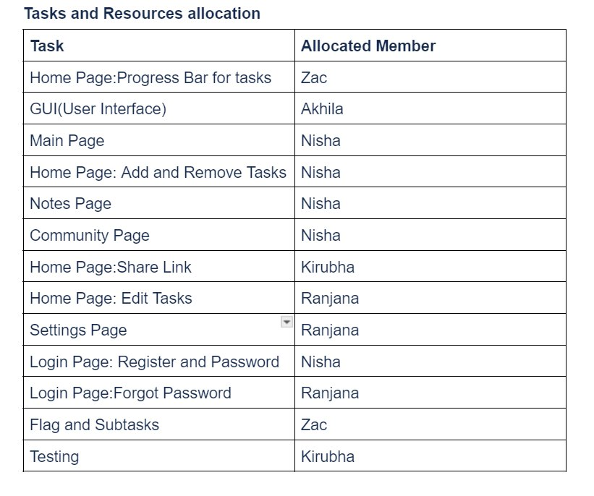
Figure 1: Task Allocation
With reference to the above table, each team member had been assigned specific responsibilities. Zac was tasked with creating the progress bar for tasks on the home page and managing the flag and subtasks feature. Akhila was responsible for the graphical user interface (GUI) design, ensuring the user interface was user-friendly and functional. Nisha worked on the main page, notes page, community page, and the features for adding, removing, and user registration. Kirubha was responsible for testing and the implementation of the share link feature on the home page. Finally, Ranjana was tasked with the settings page which serves to set a profile picture of the user, reset password, features such as editing tasks, and the password recovery (forgot password) feature. This clear allocation ensured that all critical functionalities of the app were efficiently divided among the team, enhancing collaboration of teamwork and productivity.

Gantt Chart
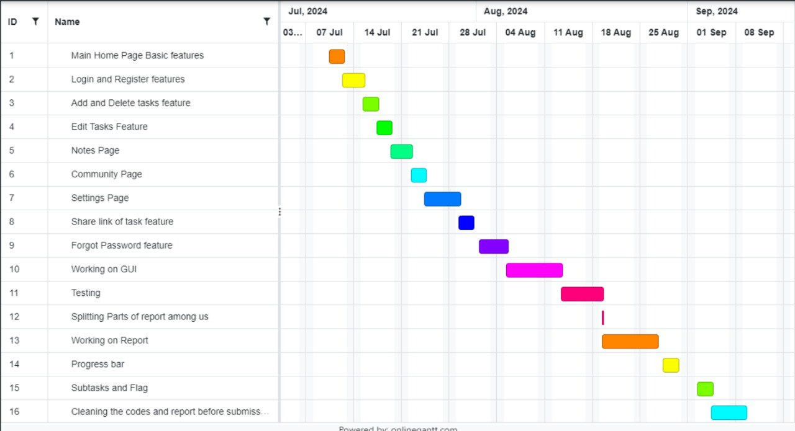
Figure 2: Gantt chart of plan

The Gantt chart provided a detailed breakdown of the time allocated for various tasks throughout our project, reflecting a clear and organised division of responsibilities among the team. In the first half of July, we focused on implementing essential features such as the Main Home Page, Login and Register functions, and task editing capabilities. The second half of July concentrated on developing more user-interactive elements, including the Community page, Notes page, Task editing and the Share Link feature.As we entered the first two weeks of August, significant efforts were devoted to refining the project’s design through CSS development and thorough testing. Toward the end of August, attention shifted to report preparation, with the team dividing sections to ensure a comprehensive approach. From the final week of August into early September, the focus turned to implementing key features like the progress bar, subtasks, and the Flag function, which prioritised tasks based on their importance.The Gantt chart illustrated our team's time management strategy, showing overlapping and successive tasks that ensured everyone had ample time to complete their responsibilities. This approach allowed us to stay on track with the overall project timeline while balancing individual contributions effectively.

Design and Development

Design Specifications

Overview
This design specification outlines the development of a task management application aimed at enhancing productivity and organisational efficiency. The application is engineered using a stack that includes Express.js, Node.js, SQLite, and TailwindCSS, with an emphasis on security and user experience. Key features of the application include task prioritisation, collaborative tools, and community engagement, all designed to provide a comprehensive, user-friendly environment for managing tasks.

System Architecture
- Backend: The application will utilise Express.js and Node.js to handle server-side logic. SQLite will be used as the database to store user information and task details securely.
- Frontend: The interface will be developed using TailwindCSS for a responsive design. The user interface will be intuitive, allowing easy navigation through tasks and features.
- Security: Bcrypt will be employed for hashing and securing passwords. The application will also implement tokenization to manage sessions securely.

Key Features
- User Authentication and Management:
  - Users can register, login, and reset passwords.
  - Secure password handling using Bcrypt.
- Task Management:
  - Create, edit, and delete tasks.
  - Prioritise tasks with visual indicators.
  - Annotate tasks with notes for detailed descriptions.
  - A progress bar to visually track the completion of tasks.
- Collaboration and Sharing:
  - Share task URLs for collaborative work.
  - View and engage with tasks shared by others.
- Community Engagement:
  - A community page where users can post completed tasks.
  - Ability to like and comment on community posts.
This task management application is designed to be a robust tool for enhancing productivity and fostering community engagement among users. By leveraging modern technologies and best practices in development, the project aims to deliver a secure, efficient, and user-friendly product that meets the needs of diverse users.

Testing

White box testing
White box testing, also known as clear box or glass box testing, is a technique where the internal structure, design and implementation of the item under test are known to the tester.This approach is important in software development especially to understand how the internal workings of an application function. The task management application was created and white box testing was used for core functionalities with the purpose of finding as many problems and errors as possible.

Test environment
- Node.js and Express: The server-side environment and framework used for building the application.
- SQLite: A lightweight database used for managing data during testing.
- Mocha and Chai: Testing frameworks used for writing and executing tests.
- Supertest: A tool used for testing HTTP endpoints.

Test cases
- User Registration and Authentication:
  - Render the registration and login pages.
  - Register a new user.
  - Handle the registration of an already existing user.
  - Log in with valid credentials, invalid email, and incorrect password.
  - Log out the user.
- Task Management:
  - Render the home page with user tasks.
  - Create, update, and delete tasks.
- Note Management:
  - Render the "Add a New Note" form.
  - Create a new note and render the notes page.
  - Should delete a note and redirect to the notes page.
- Community Interaction:
  - Render the community page with pictures.
  - Increment the like count for a picture.
- Settings Management:
  - Render the settings page for authenticated users.
  - Return an error if new passwords do not match.
  - Return an error if the current password is incorrect.
  - Update the user’s username.

Test execution and results
The tests were executed in an isolated environment where a test database was created and populated with mock data. Each test was designed to cover specific areas within the application to ensure that they were valid.
- User Registration and Authentication: All user authentication tests passed successfully. The system correctly handled registration, login, and logout processes.
- Task Management: Task creation, update, and deletion functionalities worked as expected.
- Note Management: Note creation, retrieval and deletion were successfully tested, with the application displaying the correct information.
- Community Interaction: The community page was displayed fine and the like functionality was working and was able to update the database as expected.
- Settings Management: The application handles settings changes properly, with errors being returned when necessary (e.g., mismatched passwords).
White box testing was particularly useful during the development of the task management application as it helped to identify any problems within the application and with its internal processes. Thorough testing of core competencies ensured that the project team produced a stable application that meets the project specifications and user requirements.

Design Iteration - first iteration
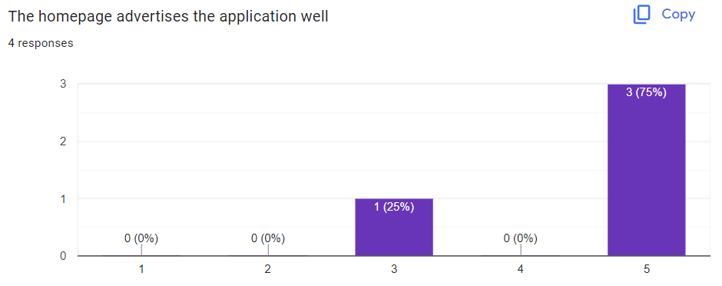
Figure 3: User Testing 1 - “The homepage advertises the application well”

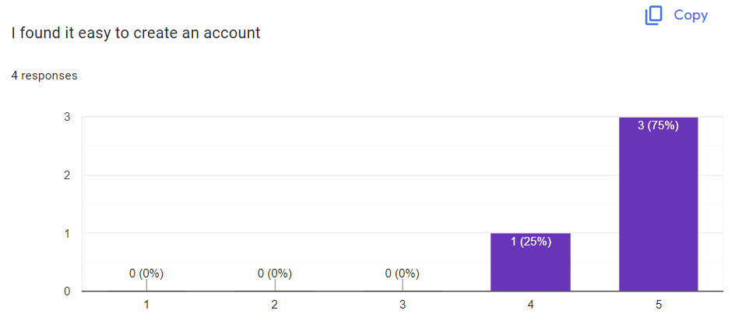
Figure 4: User Testing 1 - “I found it easy to create an account”
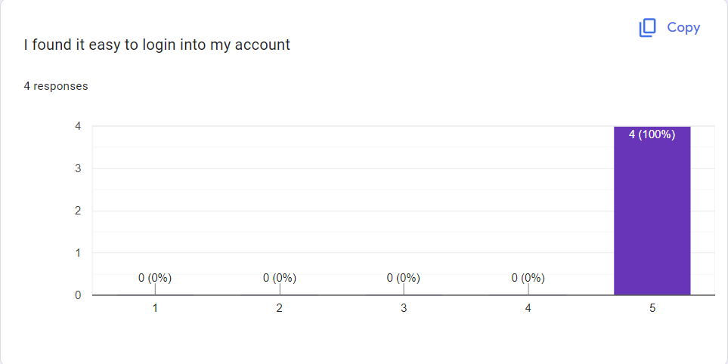
Figure 5: User Testing 1 - “I found it easy to login into my account”
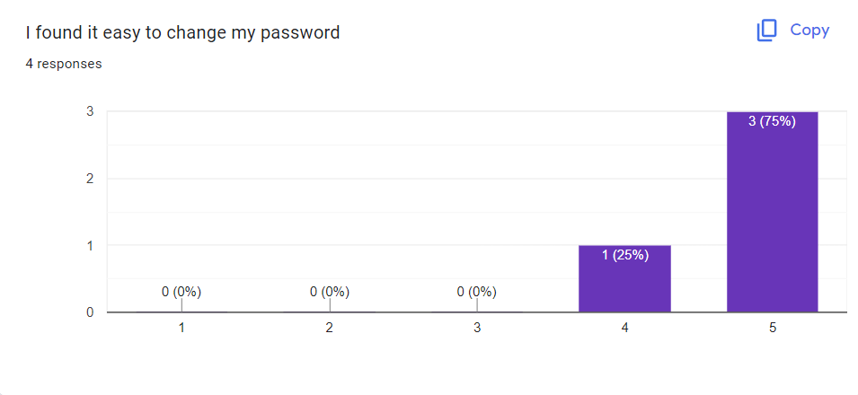
Figure 6: User Testing 1 - “I found it easy to change my password”
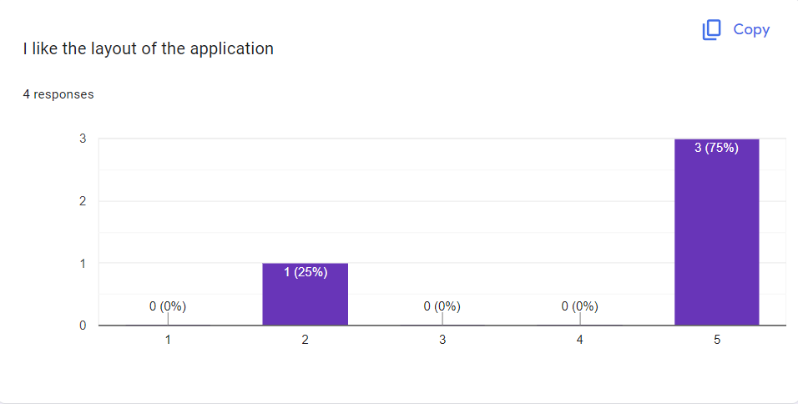
Figure 7: User Testing 1 - “I like the layout of the application”
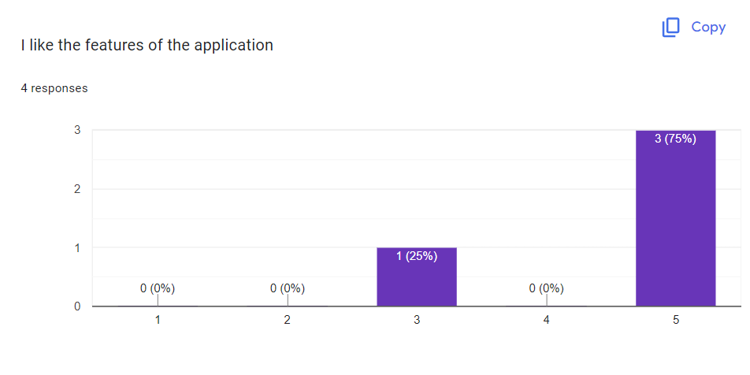
Figure 8: User Testing 1 - “I like the features of the application”
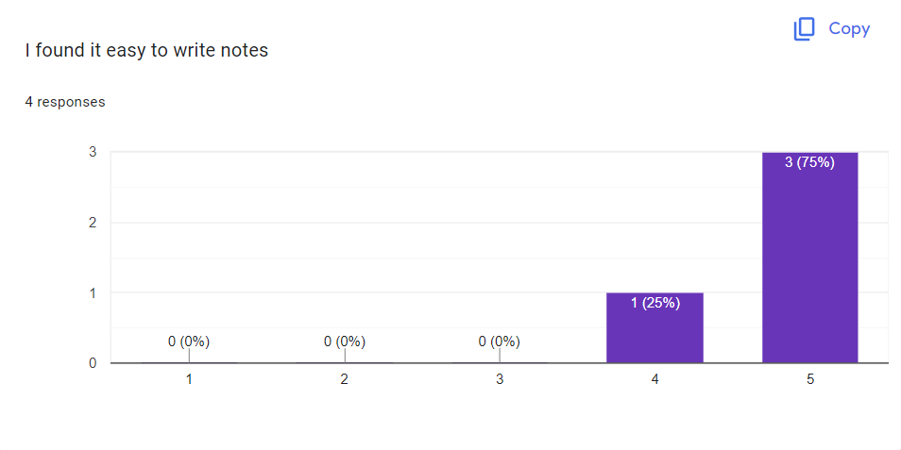
Figure 9: User Testing 1 - “I found it easy to write notes”
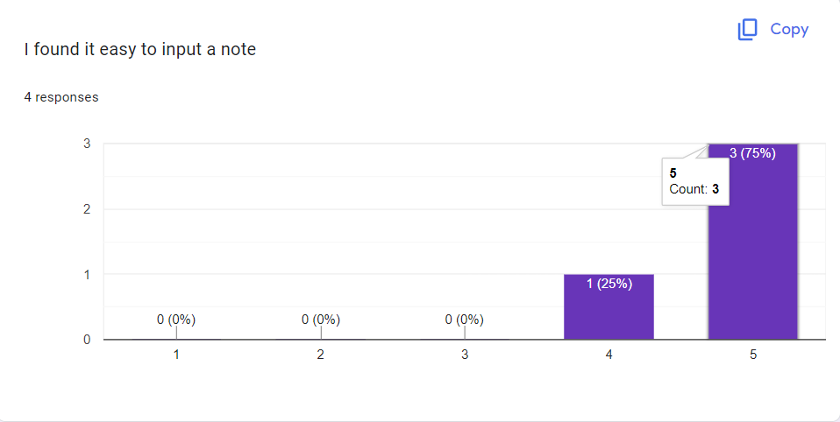
Figure 10: User Testing 1 - “I found it easy to input a note”
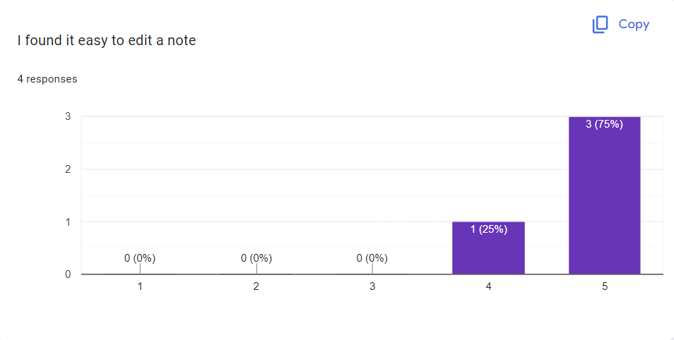
Figure 11: User Testing 1 - “I found it easy to edit a note”

In general, participants seemed to enjoy the layout and design of the website, even though it did not offer all the features we suggested it would. The homepage of the website contained information about the application and was formatted exactly like in the wireframes. Most of the participants stated that the homepage advertised the application well, but some disagreed. Hence moving forward, some changes will be made to the layout of the homepage
Participants generally had an easy time with the account settings. They could easily make their accounts, log into their accounts, and make changes to their passwords when necessary.
Most participants liked the layout of the application and the features except for one. Some changes were made to the layout of the application to appease the one user and to ensure that they enjoyed using the application.
Overall, the main changes to make for the next iteration are to change the layout of the homepage, change the layout of the application, and ensure that the colour palette of the webpage is consistent throughout the entire website and application.

Overall - second iteration
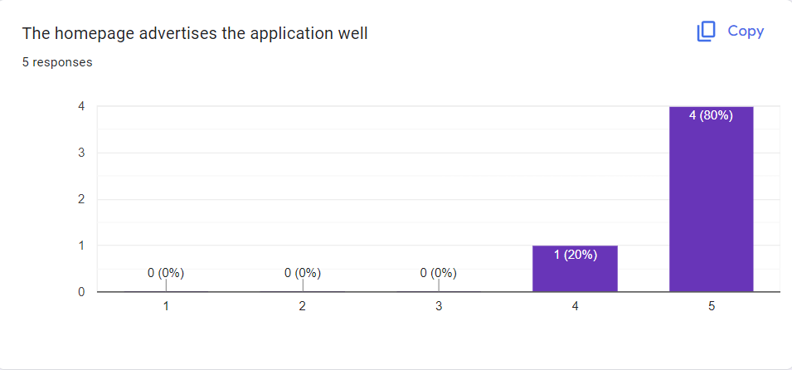
Figure 12: User Testing 2 - “The homepage advertises the application well”
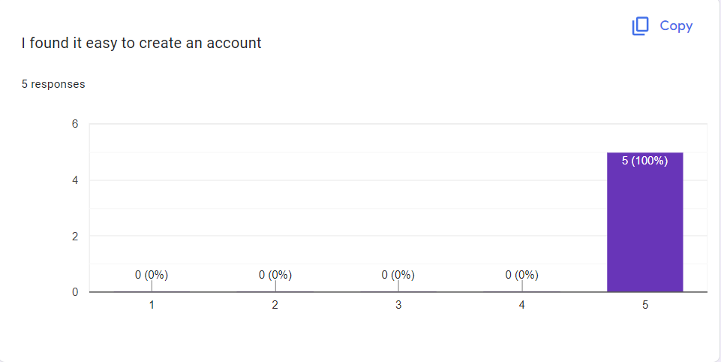
Figure 13: User Testing 2 - “I found it easy to create an account”
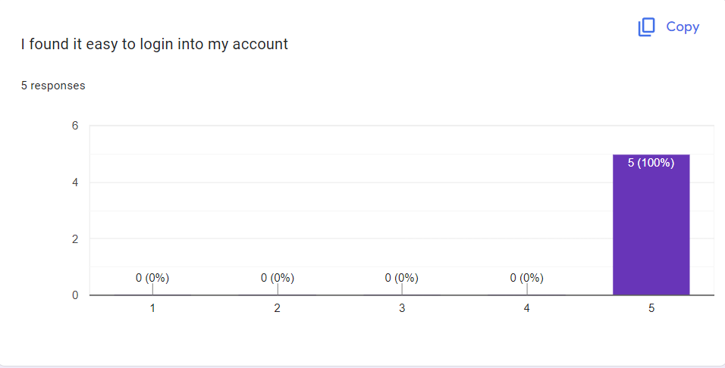
Figure 14: User Testing 2 - “I found it easy to login into my account”
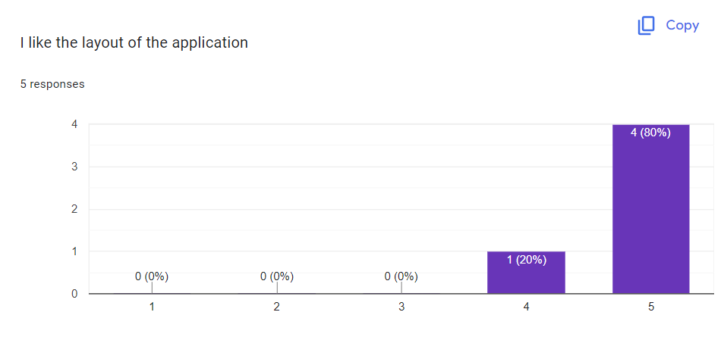
Figure 15: User Testing 2 - “I like the layout of the application”
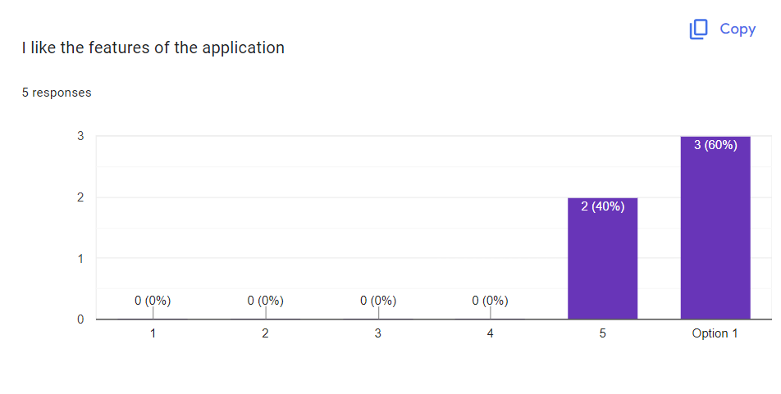
Figure 16: User Testing 2 - “I like the features of the application”
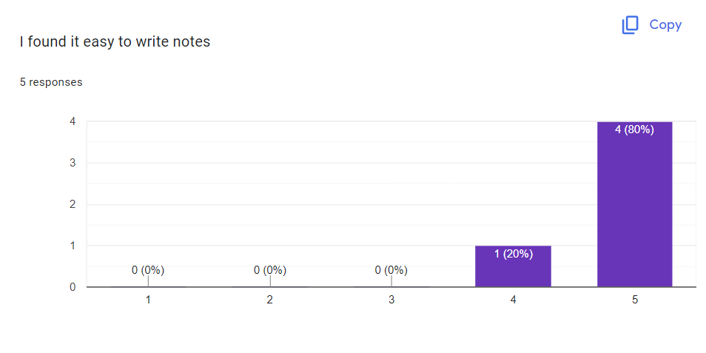
Figure 17: User Testing 2 - “I found it easy to write notes”
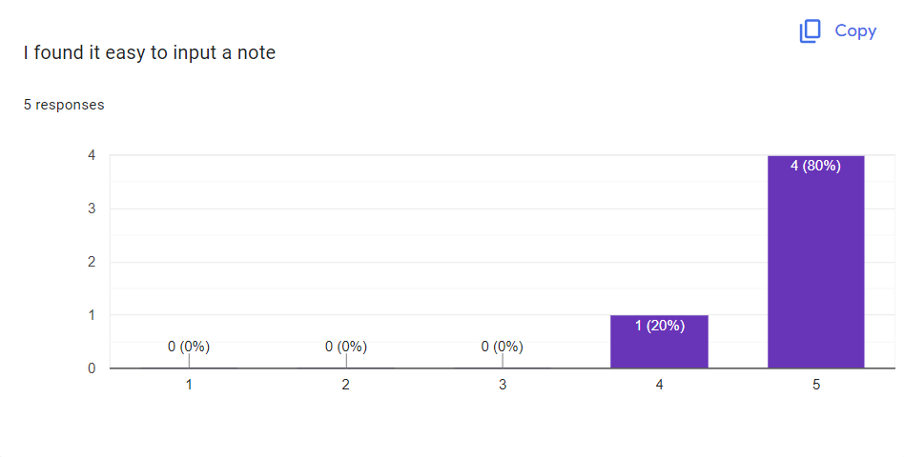
Figure 18: User Testing 2 - “I found it easy to input a note”
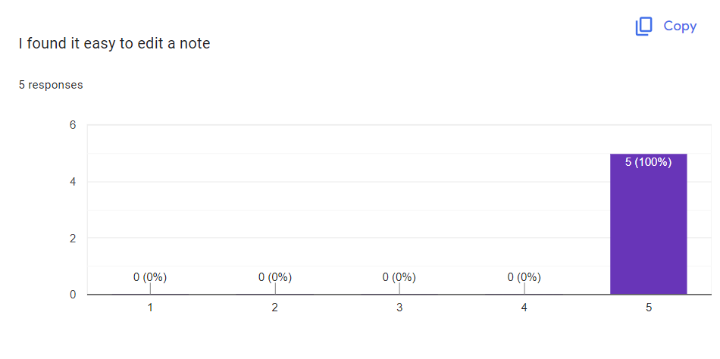
Figure 19: User Testing 2 - “I found it easy to edit a note”
Changes were made to the design based on responses from participants, and then participants were asked to do the survey again to review the website and application.
Participants seemed to enjoy using the second iteration of the website more than the first iteration. The second iteration used a different colour scheme with a slightly different application layout. The homepage of the website was changed to incorporate a hero section and text over the section to make it seem more “aesthetically pleasing”. All the pages incorporated an indigo and white colour scheme, and the users seemed pleased with it.
Overall, this iteration seemed to do better with the participants. The layout was different, as well as the colour scheme, but participants seemed to prefer this option a bit more than the other. Even though there were quite a few small changes, participants still felt like it was easy to manoeuvre the website and application.

Heuristic Evaluation
A heuristic evaluation therefore takes place by checking a user interface against the formulated usability principles. An in-house team conducted analysis of the task management app is provided below, with an emphasis on the primary features and interaction.

1. Visibility of System Status:
The app should offer informative responses, for instance, using the login name to greet the user on the homepage, which informs the user that the app knows their login status. Options like “Edit,” “Share,” or “Remove” placed as action buttons will give users an immediate perception of what they can do.

2. Match Between System and the Real World:
Familiar phrases such as “add new task”, “edit”, and “remove” corresponding with users’ expectations should be included thus the interface operates smoothly. How users organise and manage tasks should be reflected in the layout of the tasks in a table format with columns such as Title, Description, Date and Time.

3. User Control and Freedom:
Users should be able to edit, share or delete the tasks, meaning that they are in a capacity to control their entries. The UI has to provide functional buttons like logout, settings positioned where the user frantically clicks it when they need to use the system without focusing much on where they are clicking.

4. Consistency and Standards:
This should be in line with general web app aesthetic, the icons and place of buttons (settings and log out, for instance, are on the top right corner).

5. Error Prevention:
In terms of simplicity, the forms to create and update tasks and notes must be quite uncomplicated, which will eliminate the chances of users making mistakes while inputting the required details in respective fields.

6. Recognition Rather Than Recall:
The concept of the application will also be effective in the recognition process, as the interface buttons will be easily visible and clearly labelled with actions such as ‘Edit,’ ‘Share,’ ‘Remove,’ ‘Settings,’ ‘Community,’ and ‘Logout.’ This will ensure that clients will not need to memorise steps, making the user experience more intuitive and straightforward.

7. Flexibility and Efficiency of Use:
Users should be able to manage tasks and notes from the homepage as it will ease the handling of tasks and won’t require a lot of time to access a particular item.

8. Aesthetic and Minimalist Design:
The layout should be simple and clean with primary and necessary icons and buttons to make the users use the application without much distractions.

9. Help Users Recognize, Diagnose, and Recover from Errors:
The error messages should be explained in plain language and should state clearly what has gone wrong and redirect to the appropriate page.

10. Help and Documentation:
As the app uses a simple and minimalistic design and all the functions are clearly displayed, the users probably may not need much help or instruction to efficiently use the app.

Initial Design
The initial design chosen was the second prototype in the progress report (refer to appendix A). This prototype was chosen because it was designed after surveying participants regarding what they would like in a task application. The first prototype was changed to implement features that users wanted in a task application, which led to creating the second prototype.
The team decided to stick with the second prototype because users liked the features more, and it seemed to resemble task applications already available on the market.

Production prototype, first iteration
For the first production of the prototype, we tried to stick to the initial wireframes we had drawn out. However, there were some issues with incorporating all the features that we wanted to implement, and so we decided to go with a slightly different design instead.
The initial webpage was similar to the one that of our prototype. We decided to stick with having a navigation bar with the logo towards the left side, and the login and sign up button towards the right. The layout of the information regarding the application was the same as well, but the background was white instead of blue, and the navigation bar was grey. A footer was added as well
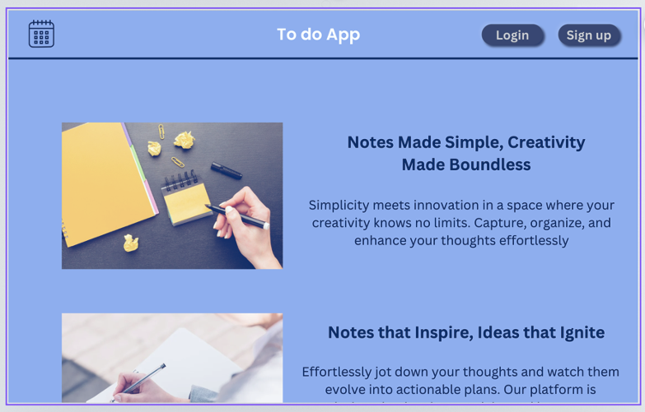
Figure 20: High-fidelity prototype of webpage
The main changes were in the application page. We ended up removing the sidebar, subtasks options, and the calendar as we had a hard time implementing it. Instead, we decided to have a homepage that showed all the tasks, and created a separate page where users could add certain notes that they wanted to keep.
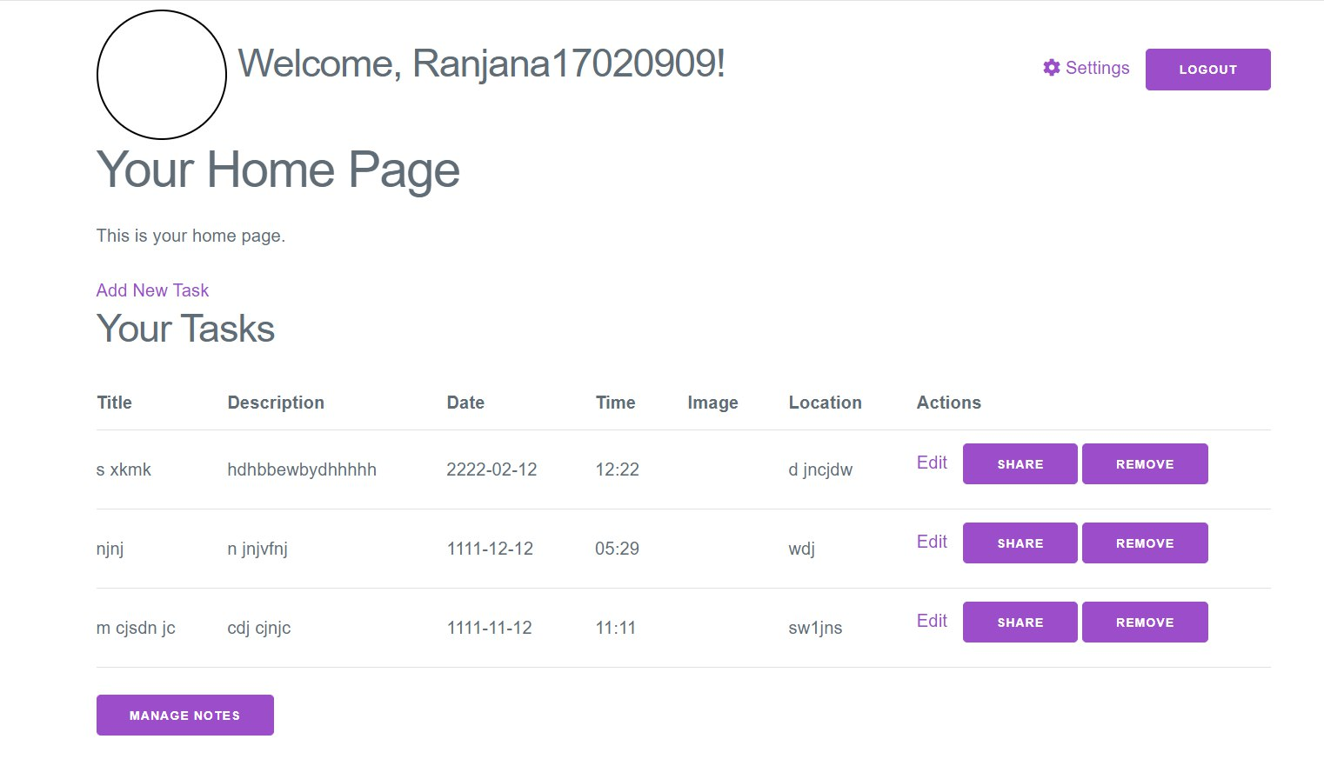
Figure 21: First iteration of prototype - application homepage

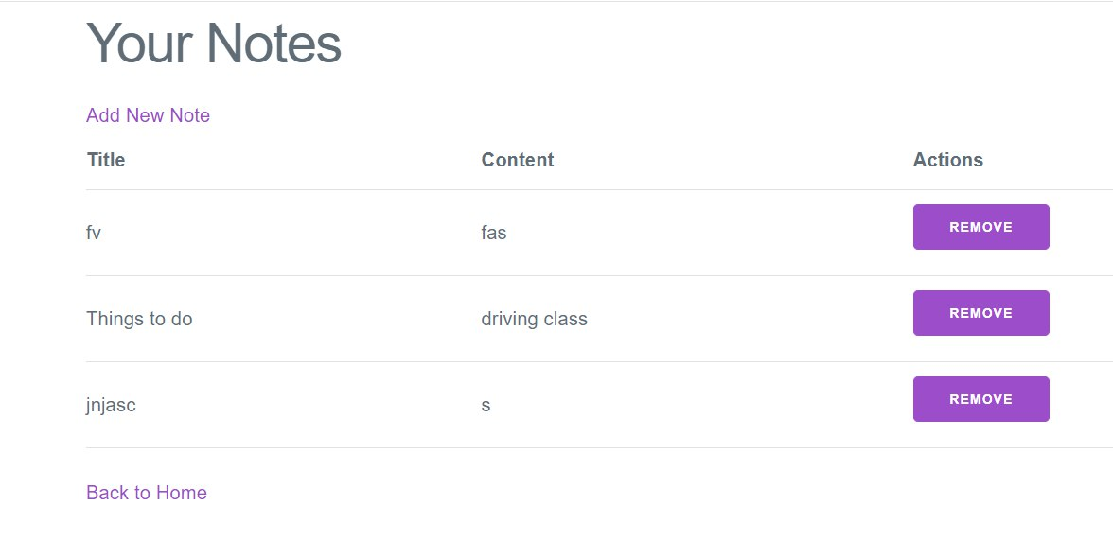
Figure 22: First iteration of prototype - note
We also added an option for users to be able to edit their username as well as their passwords. But there were issues with changing the username. Tasks made under a certain username would not show up if that user changed their username. Hence the idea of incorporating username changes was scrapped.
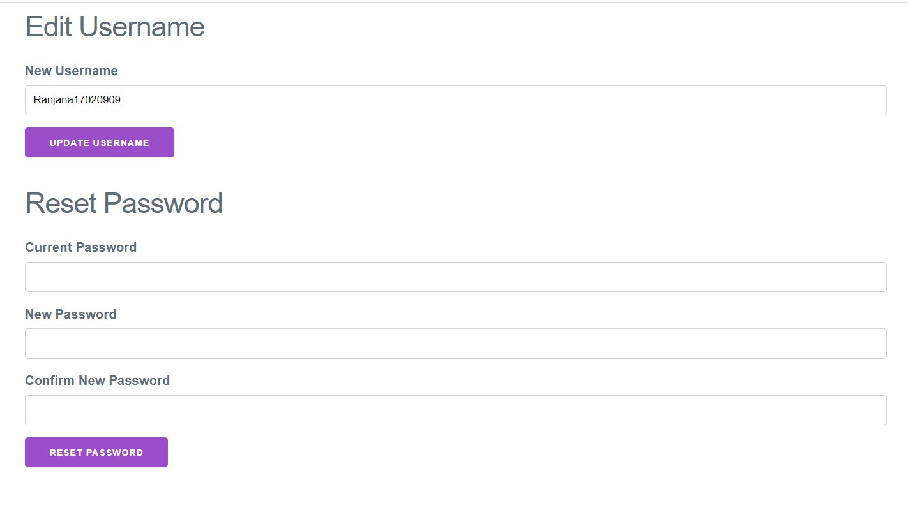
Figure 23: First iteration of prototype - settings page

Secondary Design
The secondary design was made based on user feedback on the initial design. There were changes mainly implemented on the main webpage and the colour palette and the layout of the other webpages was slightly modified.
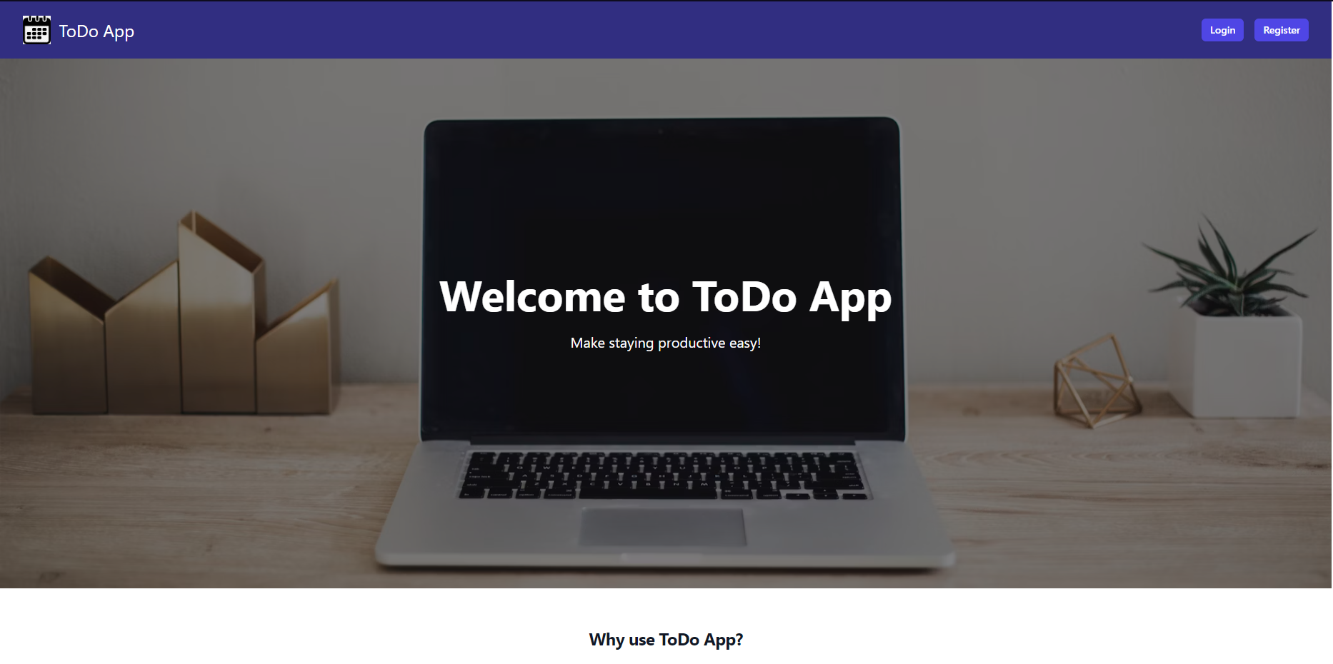
Figure 24: Second iteration of prototype - application homepage 1
The main changes to the website were the colour scheme. The colour scheme chosen was indigo, white and grey. On the first webpage, the layout was changed to include an indigo navigation bar, with a hero section with an image in the background and text over. There is some information about the task application below the hero bar, and there is a footer below everything else.
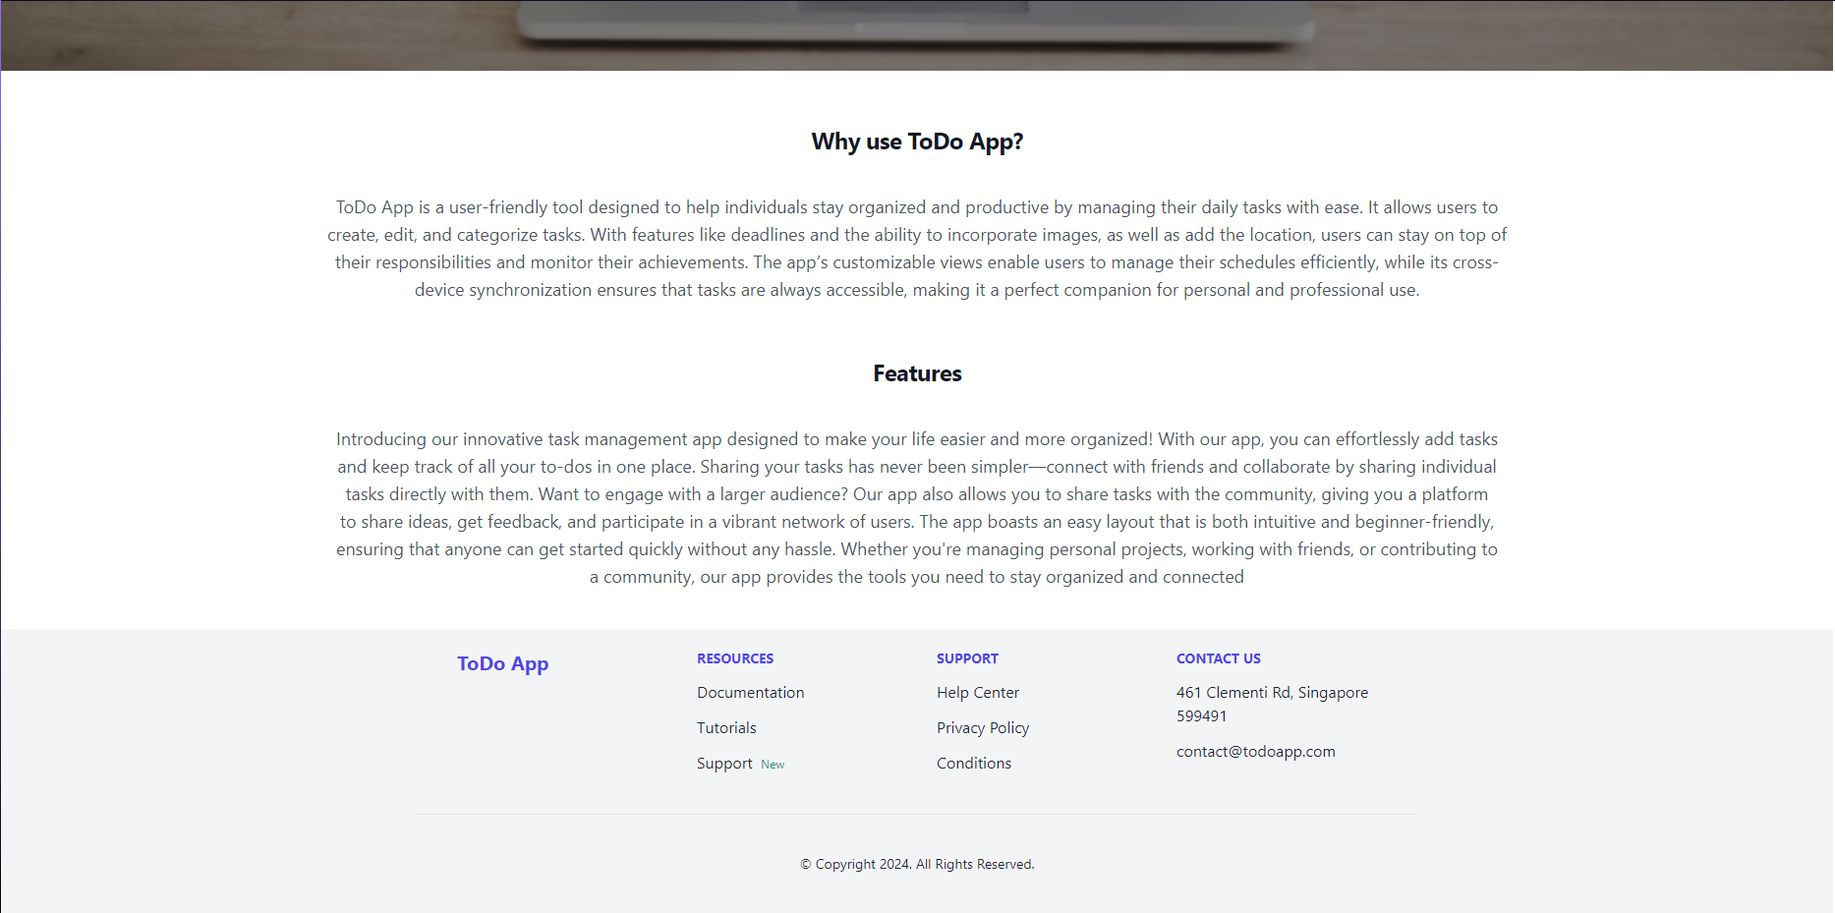
Figure 25: Second iteration of prototype - application homepage 2

There were minute changes made to the homepage after the user logs in. The layout was similar, but a navigation bar was introduced. This navigation bar has the user’s profile picture and name on the left and the settings and log out button on the right. Below the navigation bar, there is a line to welcome the user, and then the user can see their tasks, choose to add tasks, go look at their notes, or go view the community page of the application.
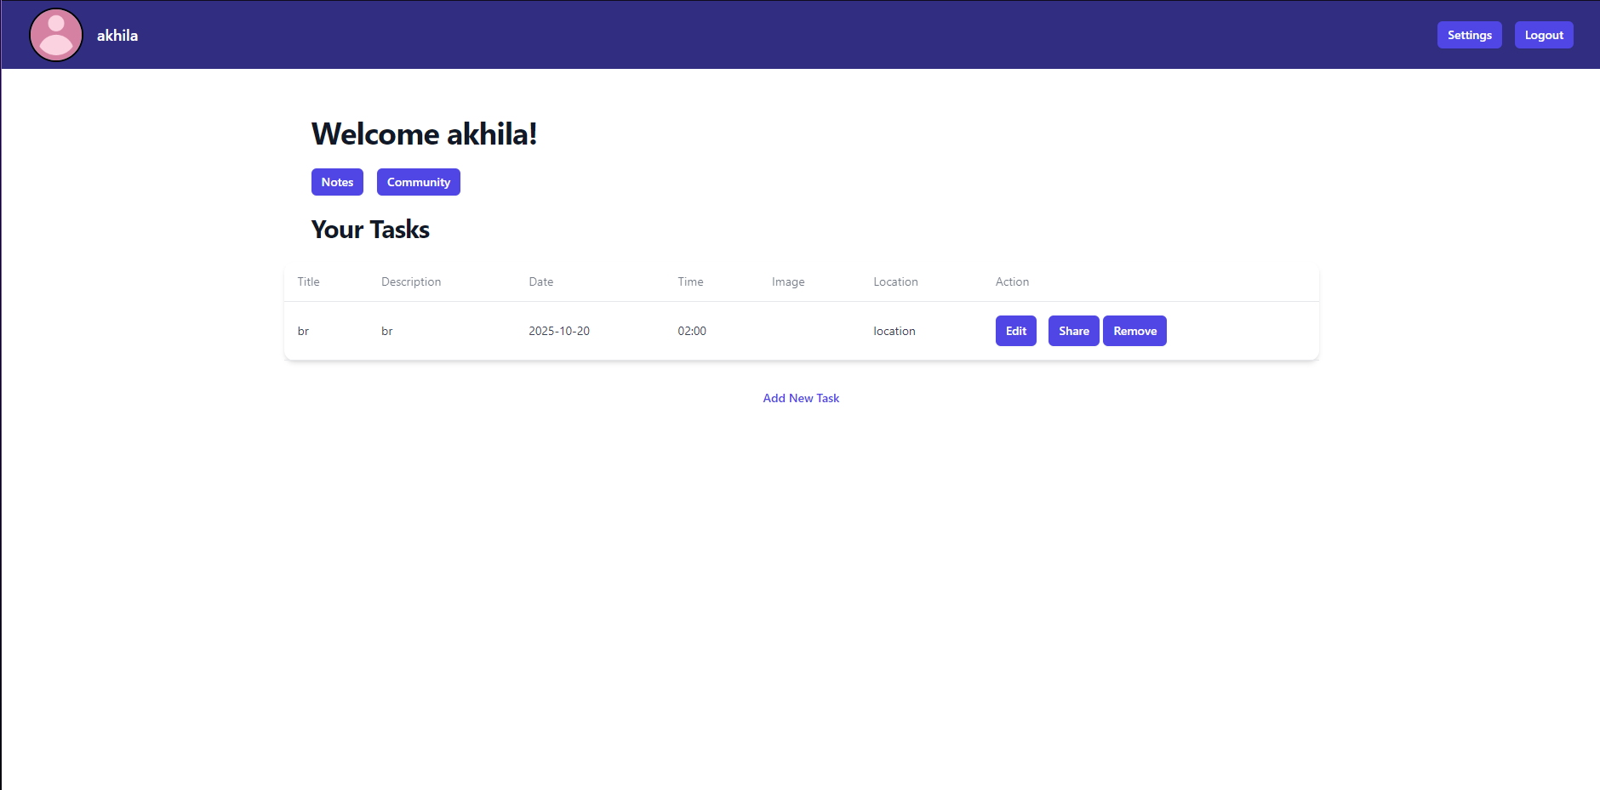
Figure 26: Second iteration of prototype - application homepage

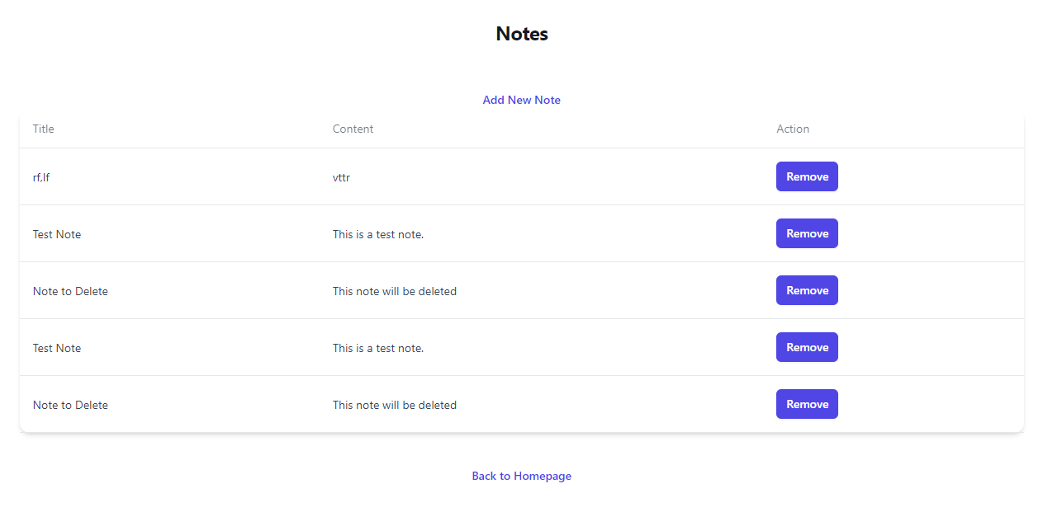
Figure 27: Second iteration of prototype - note

The were new changes implemented in the settings where users were now able to change their password there, as well as change their profile picture.
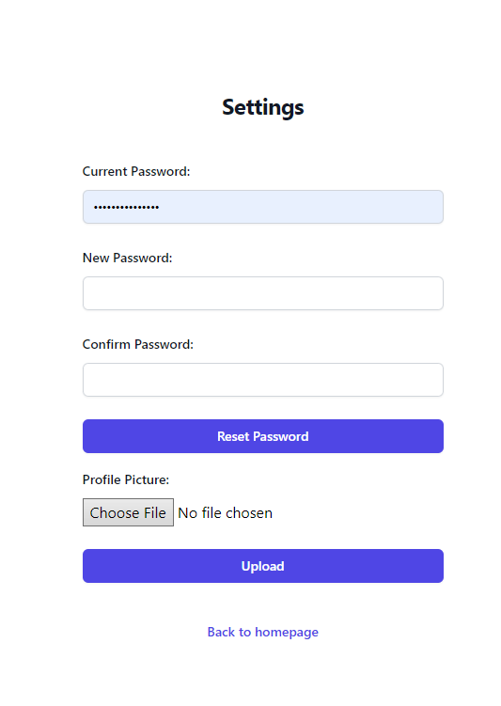
Figure 28: Second iteration of prototype - settings page”

Three Tier Architecture

Presentation Tier
The presentation tier is responsible for the user interface and interaction. It includes all the front-end components that users interact with, such as the registration, login, note creation, and management pages.

- HTML/CSS/JavaScript: Underlying technologies for the web application’s front-end.
- Express.js: For rendering dynamic content on the server-side.

In agile sprints, the presentation tier is typically the most dynamic or upgraded frequently because of feedback incorporation. Interfaces including the user authentication mechanism, the overall task management and the note-taking capability are designed and iteratively improved after analysing the user stories and acceptance criterias.

Application Tier
This middle tier computes the requests coming from the presentation tier, decides which data to retrieve from the database or which data to write to the database. It includes routing, authentication logic, note management, task handling, and user settings management.

- Node.js/Express.js: The main server-side framework that handles incoming requests, routes them to appropriate controllers, and processes business logic.
- Bcrypt: Used for handling password encryption and validation during user authentication.
- Supertest/Chai: Used for testing the various routes and ensuring the business logic works as expected.

It is worth mentioning that the application tier is constantly released and refactored during the agile sprints. Both unit and integration tests can be helpful as they allow checking that changes to one part of the system do not impact others, which complies with the agile principle of keeping the application usable throughout the process.

Data Tier
This tier is involved in processing, storage and retrieval of data as well as organising them for easy access. It is responsible for all databases where personal information and other such details like user credentials, notes, tasks, etc, are stored. The database layer communicates with the application tier with help of SQL interfaces in order to save information.

- SQLite: A lightweight relational database used for storing the application data.

The data tier is built to be simple and flexible to accommodate data changes over different deployments. In agile, changes and modifications to Database schema and migration are handled cautiously so as not to interrupt the developmental process that is going on actively; there are test strategies set in place to ensure the validity of the changes before they are implemented.

Structure and Implementation

Project Structure
The task management application is organised into a structured directory layout to facilitate development and maintenance. Key directories include index.js for controllers, models, routes, and services handling business logic, database models, routing, and external services, respectively. The config directory contains setup files for database connections and authentication configurations. Static asset JavaScript is placed in the public folder, while views houses CSS and EJS templates for layouts, pages, and reusable fragments. Testing scripts are located in the test directory, categorised into unit and integration tests. The project’s entry point and dependency management are handled by package.json.
Technology Stack
The backend is powered by Node.js and Express.js, with SQLite handling data storage to facilitate relational database management. Front End styling is managed with TailwindCSS, and EJS is used for server-side templating. Security features are robust, incorporating Bcrypt for password hashing. Testing is conducted using Mocha, Chai, and Supertest to ensure reliability and performance.
Backend Implementation
Database models such as db_schema.sql define the schema for user information and task details, respectively. Controllers handle the business logic; manages user authentication processes and oversees task-related operations. Services handle token-based user authentication and email notifications, enhancing the application’s functionality and user interaction.

Frontend Implementation
The frontend utilises EJS for templating, with layouts for consistent page structures and partials for reusable components. TailwindCSS aids in creating a responsive design that adjusts to various device screens, ensuring a user-friendly interface. The frontend connects seamlessly with the backend, providing a dynamic and interactive user experience.

Security Measures
Security is paramount, with Bcrypt used to securely hash user passwords. This ensures that user data is protected against unauthorised access and manipulation.

Testing and Deployment
Testing is thorough with unit tests for individual components and integration tests for component interactions, using Mocha, Chai, and Supertest..

Development Workflow
Development follows a disciplined workflow using Git for version control with GitHub as the repository platform. Continuous integration and continuous development is implemented to automate the deployment and testing phases, ensuring that each build is tested before deployment, which helps in maintaining code quality and operational reliability.

Data Layer and Database Management

Security Features

1. Token Generation
- Random and Unique:
Tokens are generated using secure random methods (crypto.randomBytes), ensuring each token is unique and unpredictable. This prevents attackers from guessing valid tokens.Hence,users receive a unique code that is difficult to replicate, adding a layer of trust in the security process.
- Time-Limited Validity:
Each token has an expiration time (1 hour), after which it becomes invalid. This limits the chances of misuse of a token if it is intercepted.This will encourage users to initiate timely setting of passwords hence reducing the risk of prolonged exposure.
2. Association with Specific Users
- Linking Tokens to User Accounts:
Tokens are tied to specific usernames in the database, ensuring that a token can only be used to reset the password of the intended user.Users can trust that their password reset request is secure and personalised, preventing unauthorised access to their accounts.
3. Secure Storage of Tokens
- Storing Tokens Safely:
Tokens and their expiration times(resetTokenExpiry in database) are stored securely in the database.Hence, users benefit from the assurance that their reset tokens are handled with confidentiality .
- Token Validation:
Upon receiving the token, the system verifies:
The system checks if the token exists and is correctly associated with the user and ensures the token has not expired. Users are informed if their token is invalid or expired, guiding them to request a new one if necessary.

6. User-Friendly Security Enhancements
- Guided Reset Process:
The system provides clear steps for users to follow when resetting their passwords, reducing confusion.A straightforward process enhances user experience and encourages users to maintain strong security practices.
- Feedback Mechanisms:
Informative messages guide users through successful or failed reset attempts, improving security awareness.Users receive timely feedback such as “new passwords do not match” when an user is trying to reset password and let’s say both “new password” and “confirm new password” do not match. This fosters confidence in the system's security measures.

7. App’s Overall Security Features
- Confidentiality:
Sensitive information, such as tokens and passwords, are handled securely, maintaining data confidentiality.Users can trust that their personal information remains private and protected.
- Integrity:
Ensuring that tokens are valid and unaltered maintains the integrity of the password reset process.Users experience a reliable and trustworthy system for managing their account security.
- Availability:
Providing a robust password reset feature ensures that users can regain access to their accounts when needed, without compromising security.Hence,users have confidence that they can securely recover their accounts in case of forgotten passwords, enhancing overall user satisfaction.
- Session Management:
Used express-session to manage user sessions, ensuring that only logged-in users can access certain routes like the home page, settings, and task management pages.
- Password Hashing:
Utilised ‘bcrypt’ to hash user passwords before storing them in the database. This ensures that passwords are securely stored and not saved in plain text.
- User Authentication:
Login functionality checks user credentials by comparing the hashed passwords with ‘bcrypt’, ensuring secure authentication before granting access.
- Authorization Middleware:
Implemented middleware that checks if a user is authenticated before accessing protected routes (like task creation or community features).

- Secure File Uploads:
Used ‘multer’ to handle profile picture and image uploads, specifying a destination folder and unique filenames to avoid overwriting files.
- Password Reset Feature:
Included a password reset mechanism where users must verify their identity with a current password before setting a new one, with the new password being hashed before storage.
- Logout Mechanism:
Upon logout, sessions are destroyed, ensuring no unauthorised access after a user logs out.
- SQL Injection Protection:
SQL queries use parameterized statements to prevent SQL injection attacks when handling user inputs.
- Profile Picture Security:
Ensured that profile pictures are securely uploaded and tied to user sessions, limiting the possibility of unauthorised modifications.

Components of the software

User Interface(UI)
They are involved in determining the way the application will be used most especially by the end user. This includes the visual elements and the interaction means which are utilised by users to accomplish operations within the application.

- Login and Registration Pages:
Let the user have secure access to the application. Such a page commonly contains form fields which let the user type in their username, email, or password, as well as validation means.
- Note Editor:
The page where the users input, modify, make notes, and arrange them in logically structured categories.
- Task Management Interface:
The next is a tab which allows subscribers to watch listed tasks and to add new ones, refine and sort them according to the categories. It can contain options for priorities, due dates, and completed steps, for instance.
- Settings Page:
This page allows the users to reset or change their password.
- Community Interface:
This tab allows all users to share their feedback in text and image formats and allows them to give a like to others posts which will be easy to understand that most of the users feel the same way whether it is positive or negative.

Application components
These components deal with software application’s foundational capabilities as well as operations. They are mainly charged with the responsibility of causing the software to behave in a particular manner, for instance, handling the inputs from the users, making decisions and even helping in calculations.

- Authentication Module:
It is involved in user login, registration, password encryption for security, user session management among others. It contains routines for authentication and privacy of user details.
- Note Management Module:
Responsible for creating, reading, modifying and transaction notes. It is for saving the notes into a database, using search queries on notes and for handling the content of a note.
- Task Management Module:
Responsible for all the operations of the tasks and which include creation of task, grouping, modification and removal of tasks. For example, it concerns such options as scheduling the due dates for the particular task, tagging it as done or prioritising the tasks.
- Data Validation Module:
It makes sure that the data being fed into the application (for instance, notes, tasks, or user data) do not violate the application’s standards before they are either processed or stored. This involves verifying whether all the compulsory columns are filled, proper data formats, and prohibiting redundancy.

Database components
These components are responsible for data storage, retrieval, and management. They ensure that all user data, such as notes, tasks, and account information, is securely and efficiently handled.

- SQLite Database:
A lightweight relational database that stores all the application's data, including user information, notes, tasks, and configuration settings. It is designed to handle the application's data requirements in a compact and efficient manner..
- Database Schema:
The structure that defines how data is stored in the database. This includes tables for users, notes, tasks, and any relational mappings between them.

API components
These components provide interfaces for the front-end to interact with the back-end. They manage the communication between the client-side and server-side components.

- RESTful API:
The set of endpoints that allow the front-end to communicate with the back-end. It includes routes for user authentication, note management, task management, and other operations.
- Middleware:
Functions that process requests between the client and server, often used for tasks like authentication, logging, or data parsing.
- Response Handling:
Components that manage how the server responds to client requests, including error handling, success messages, and data formatting.

Testing components
These components ensure that the application is reliable and functions as expected. Testing components are essential in agile development to maintain quality through continuous integration.

- Unit Tests:
Tests that focus on individual components, such as functions or classes, to ensure they work correctly in isolation.
- Integration Tests:
Tests that verify the interaction between different components of the application, such as the interaction between the front-end and back-end or between the application tier and database.
- End-to-End Tests:
Tests that simulate user interactions with the entire application, ensuring that the user interface, business logic, and database work together seamlessly.

Modules needed

- body-parser: This middleware is used to parse incoming request bodies, especially for ‘POST’ requests. In the task app, it allows the server to process form data for user registration, task creation, and note-taking.
- express-session: This module handles session management. It is essential for tracking logged-in users and ensuring that only authenticated users can access certain pages (like the home page and task management). Sessions also maintain the user's state across different routes.
- multer: This is used for handling file uploads. The ‘diskStorage’ configuration ensures that uploaded files are stored with unique filenames.This module allows users to upload images when creating or editing tasks, or sharing pictures in the community. It manages the process of saving uploaded files to the server and handling file-related errors, ensuring that your app can handle multimedia content.
- path: This module helps in handling file paths in a platform-independent manner. It's used to resolve paths for serving static files, saving uploads, and rendering views.
- crypto: This module is used for generating random tokens or hashes when needed. This module can be utilised for secure operations like generating tokens for password reset functionality that comes into use when users forgets their password.
- ejs: This is the template engine used to render views. It helps create dynamic HTML pages, like registration forms, task lists, and community pages, by passing data from the backend (e.g., tasks, user profile pictures) into the frontend templates.

Libraries used

Express.js


Figure 29: EspressJS logo

For our project's backend framework, we selected Express.js, a popular web application framework for Node.js. This decision was based on cm 2040 Database , network and the web as we did use Express for our mid term
Reasons for Choosing Express.js
- Minimal and Flexible Framework:
Express.js is known for its minimalistic and opinionated nature. This allows developers to build applications with the flexibility to structure the application in any way they prefer. Unlike some heavier frameworks that enforce certain patterns or configurations, Express.js provides just the essentials, enabling us to maintain control over our application’s architecture.
- Middleware and Routing Capabilities:
One of the standout features of Express.js is its robust middleware support. Middleware functions in Express.js allow us to perform operations on requests and responses, such as handling JSON data, processing form submissions, logging, authentication, and error handling. This modular approach simplifies the development process and makes our codebase more maintainable and reusable.
Additionally, Express.js provides an intuitive routing mechanism, allowing us to define routes for different endpoints in our application. This feature enables us to create a clean and organised structure for handling HTTP requests (GET, POST, PUT, DELETE, etc.) and makes it easier to build RESTful APIs.
- Extensive Ecosystem and Community Support:
As the most widely used framework for Node.js, Express.js benefits from a vast ecosystem of middleware, libraries, and tools that enhance its functionality. There is also extensive community support and a wealth of online resources, tutorials, and forums, which are invaluable for troubleshooting and learning best practices. This rich ecosystem allowed us to quickly find solutions and integrate third-party libraries for various functionalities, accelerating our development process.
- Performance and Efficiency:
Express.js is lightweight and built for speed, making it highly performant for web applications. Its minimal overhead ensures that it remains efficient even under high load, which is essential for our application that needs to handle multiple user requests concurrently. This performance efficiency directly translates into faster response times and a better overall user experience.
- Compatibility with Node.js:
Express.js is specifically designed to work seamlessly with Node.js, taking full advantage of its asynchronous nature and event-driven architecture. This compatibility means that Express.js can effectively utilise the non-blocking I/O model of Node.js, ensuring that our application can handle numerous simultaneous requests without performance degradation.
- Ease of Learning and Rapid Development:
Given our team’s familiarity with JavaScript and Node.js, learning Express.js was straightforward. Its simple syntax and clear documentation allowed us to quickly understand and implement the framework in our project. This ease of learning, coupled with the framework’s rapid development capabilities, enabled us to deliver features and functionalities within a tight timeline.
Application of Express.js in Our Project
In our project, Express.js serves as the backbone for handling all server-side operations. It manages routing, middleware functions, and API endpoints, enabling us to create a RESTful backend that interacts seamlessly with our frontend and database. For example, we used Express.js to create routes for user authentication, task management, and other core functionalities, ensuring that our application is modular, scalable, and easy to maintain.

Node.js

Figure 30: Node.js Logo
For the backend development of our application, we chose Node.js as the primary technology. This decision was made after considering several factors, including our project requirements, our team's familiarity with JavaScript from (cm1005 ,cm1010) ,cm1040 and cm2030), and the Node.js from (cm2040)
Reasons for Choosing Node.js
- JavaScript Everywhere: Node.js allows us to use JavaScript for both frontend and backend development. This unified language approach reduces the learning curve for developers who are already familiar with JavaScript on the client side. By using JavaScript throughout the stack, we streamline our development process, improve productivity, and enhance code consistency.
- Non-Blocking, Event-Driven Architecture: One of the core strengths of Node.js is its non-blocking, event-driven architecture. This feature makes it ideal for handling multiple simultaneous connections efficiently. For our application, which involves numerous user interactions and real-time data updates, Node.js's ability to handle asynchronous operations is crucial for maintaining a responsive user experience.
- High Performance and Scalability: Node.js is built on Chrome's V8 JavaScript engine, which compiles JavaScript directly to native machine code, making it highly performant. Its single-threaded event loop mechanism allows it to handle a large number of concurrent requests with minimal overhead. This performance and scalability are particularly beneficial for our application, ensuring it can grow and handle increased load as our user base expands.
- Rich Ecosystem and Community Support: The Node.js ecosystem is vast and continually growing, with a rich set of libraries and modules available through npm (Node Package Manager). This extensive ecosystem allows us to leverage existing tools and frameworks to accelerate development. Additionally, the active community support around Node.js ensures we have access to a wealth of resources, tutorials, and forums to assist with any challenges we encounter.
- Microservices and Real-Time Applications: Node.js is particularly well-suited for developing microservices architectures and real-time applications. Our project benefits from Node.js’s capability to create lightweight, modular services that can communicate efficiently. This approach enhances the flexibility and maintainability of our application, allowing us to build and deploy features independently.
- Ease of Learning and Development: Given that many of our team members have a background in JavaScript, adopting Node.js was a natural choice. The learning curve was minimal, allowing us to quickly ramp up development efforts. Node.js’s straightforward setup and extensive documentation further facilitated a smooth transition into building our backend services.
Application of Node.js in Our Project
In our project, Node.js serves as the backend runtime environment for handling all server-side logic, including user authentication, API requests, and data processing. It interacts with our SQLite database to manage data storage and retrieval efficiently. By leveraging Express.js, a popular web application framework for Node.js, we were able to set up robust routing, middleware, and error-handling mechanisms, streamlining the development process and enhancing the scalability of our application.

SQLite

Figure 31: sqlite logo

To store the data e.g. login credentials , task, etc . We initially chose mongo db and tried learning it through udemy course but we had hard time learning and due to time constraints we decided to drop that and use sqlite as we were quite proficient in it because of cm 2040 Database , network and the web as we did use sqlite for our mid term.

Sqlite was a good choice for this application as it is lightweight and an efficient database system. Comparing to other database sqlite is is easy to set up and does not requires any configuration make it ideal for application and portable database
The data in this project is organised into separate tables within a single SQLite database file. Each table is designed to manage specific types of data, ensuring data organisation and integrity without requiring tables to share data directly. For example, the notes table is used to store user-specific information such as id, title and content. Each data field is stored in its respective column, and each user’s data is stored in a separate row.
ER diagram

TailwindCSS
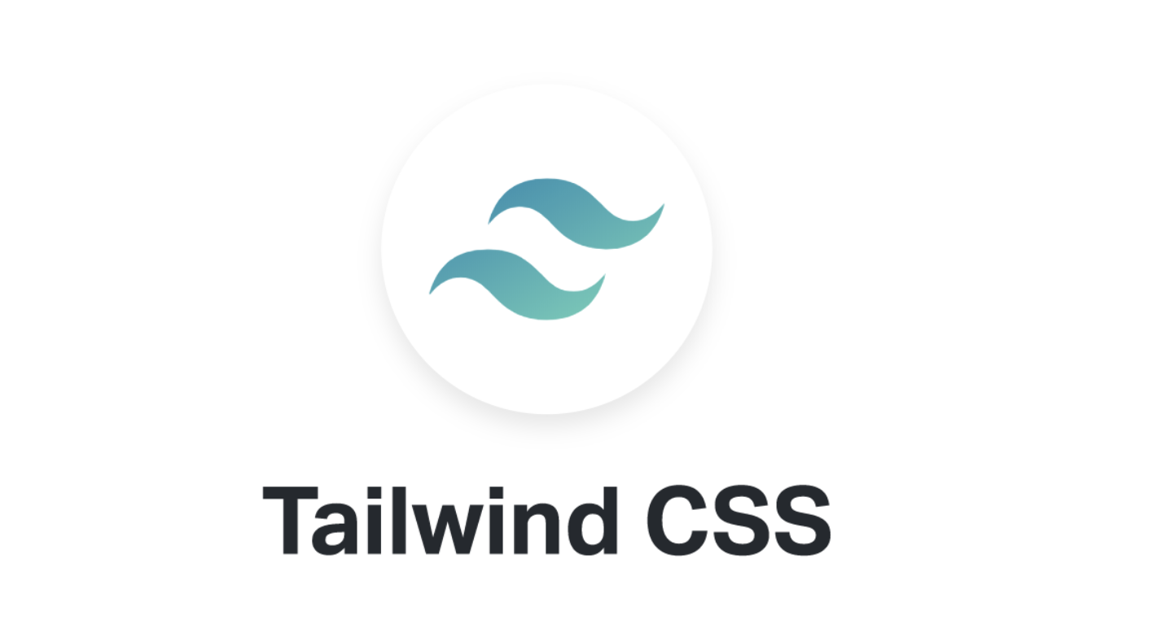
Figure 32: Tailwind css logo
To aid in the styling aspects of the website, the TailwindCSS library was used. TailwindCSS is an “utility-first CSS framework” and it helps developers create applications in a quicker, and easier manner. The library uses utility classes to design the application. Developers can use the utility classes to change the colour, layout, shape and shadows. They can do so in the HTML sheet itself without having to write in a separate CSS file. This improves the developer experience and greatly reduces the amount of code that the developer needs to write.
TailWindCSS is a low-level framework that does not offer fully styled components. But, because it is low level, it offers a lot of flexibility to the developer and makes it easier for them to implement unique features. It also offers the developers the ability to create their own utility classes so that it is easier for users to reuse certain custom features like buttons, cards, navbar, etc.
However, for developers to be able to use TailwindCSS, they need to have a very good knowledge of HTML and CSS unlike Bootstrap or Handlebars. Bootstrap and Handlebars are a lot more beginner friendly as they do not have a steep learning curve. There is also a lot of documentation online to help beginners learn more about using Bootstrap and Handlebars.
CSS Frameworks: Tailwind CSS
Tailwind CSS is a utility-first CSS framework that allows developers to quickly design custom interfaces using predefined utility classes.
- Educational Resources: We started with the official Tailwind CSS documentation, which provided clear instructions on how to install and configure Tailwind CSS. We also completed a Tailwind CSS course on Coursera that covered the utility-first design approach and responsive design techniques.
Development Process
Our development process followed a structured approach:
- Creating Core Functions: We began by developing the core functions such as user authentication and task management. This was based on our knowledge from various resources and courses.
- Adding Common CSS: We applied basic styling using common CSS, guided by the CSS knowledge acquired from our previous coursework and online resources.
- Integrating Tailwind CSS: We integrated Tailwind CSS to enhance the application's design. The Tailwind CSS documentation and the Coursera course were invaluable for understanding the utility-first approach.

Bcrypt
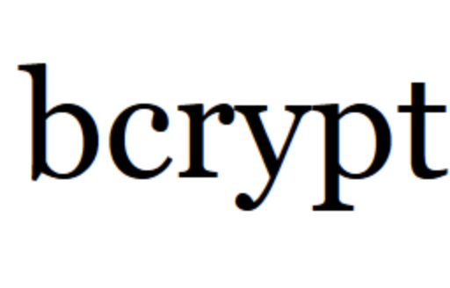
Figure 33:Bycrypt logo

bcrypt is a password hashing function designed for secure password storage. It is particularly known for its computational intensity, which adds a layer of security against brute-force attacks.
- Educational Resources: We utilised the bcrypt npm package documentation to learn how to implement password hashing and verification in our application. A helpful tutorial on Hashnode also provided a step-by-step guide on integrating bcrypt with Express.js for user authentication.

Mocha

Figure 34: Mocha logo

Mocha is an effective and prevalent javascript testing framework that performs on Node. js. This allows for a proper way of writing and carrying out tests in a manner that is systematically organised. Mocha can run both synchronous and asynchronous tests, thus allowing it to test the various parts of the applications, beginning with individual lines of code, and ending with the complex sequences of actions.

Reasons for Choosing Mocha

- Test Suite Organization: Mocha enables one to nest his tests into groups and subgroups which hence gives a sort of order to the tests.
- Hooks for Setup and Teardown: It provides before and after blocks like before, beforeEach, after and afterEach, where code execution is provided before or after the tests, good for tasks such as setting up the required environment before the tests or tearing down after the tests.
- Asynchronous Support: For instance, Mocha supports callback functions, Promises as well as async/await, thereby enabling developers and testers to test asynchronous activities such as API calls or read/write to databases or download/upload files and more.

Chai

Figure 35: chai

Chai is a tool used for assertions and is compatible with other tools including mocha for testing. It offers a tool for defining test assertions and their syntax to see whether the application behaves as it should. Chai has the capability to support various forms of assertions like BDD which stands for Behavior-Driven Development and TDD which refers to Test-Driven Development.

Reasons for Choosing Chai

- Assertion Styles: Chai provides numerous assertion manners, those include:
Expect/Should: To define human-readable tests using Behavior-Driven Development style.
Assert: For those of you who are doing traditional TDD-style of assertions where you have an expected value and a get method, etc.
- Deep Assertions: Enables the comparison of complex objects and arrays where all nested properties are evaluated for equivalence.

Supertest
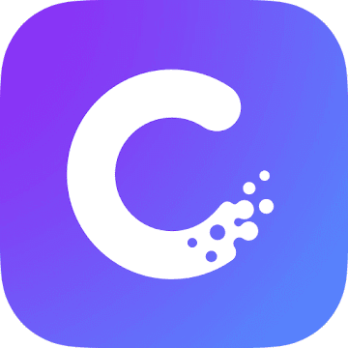
Figure 36: super test

Supertest is a great Node library that helps to test HTTP endpoints. js applications. Along with Mocha and Chai, it can be used to simulate HTTP requests (GET, POST, PUT, DELETE) so one can test how API routes work. Initiated by supertest, Supertest is most helpful when it comes to the integration testing where you need to confirm how one element or a number of elements of your application interacts with other – say, routes, the rest of the database, or business logic.

Reasons for Choosing supertest

- HTTP Request Simulation: Supertest lets you send through various requests like GET, POST and other to check your API’s response without having to prompt a browser or an actual client.
- Chaining: They can append methods such as expect() to verify the status code, response body, headers, and so much more.
- Seamless Integration: Integrates seamlessly with Mocha and Chai while used in testing of RESTful APIs in Node. js.

Evaluation

Back-end

Conceptual Issues
Scalability and Performance: Initially, the application faced potential scalability issues, particularly concerning how it would perform under high loads with many users and tasks.

Security with Authentication and Session Management: The security of user sessions and password management was a primary concern due to initial vulnerabilities in session handling. To improve security, the system integrated Bcrypt for secure password hashing. This setup helped in preventing attacks and ensured a more secure user experience.

Data Integrity and Transactions: Another major conceptual issue was maintaining data integrity when multiple users attempted to modify the same task concurrently. SQLite supports multiple simultaneous read transactions coming from separate database connections, possibly in separate threads or processes, but only one simultaneous write transaction. Using SQLite’s transactional capabilities allowed us to ensure that task updates were handled efficiently, avoiding race conditions and ensuring consistency across the database.

Technical Issues
Database Schema Design: The project initially struggled with a database schema that was not optimised for the required queries, leading to slow performance and difficulties in task prioritisation. By revising the schema to include *indexing and optimising table relationships for JOIN operations, database interactions were streamlined, improving performance.

Integration of TailwindCSS: Integrating TailwindCSS while maintaining responsiveness and accessibility across various devices was challenging. By adopting a mobile-first design and using Tailwind’s responsive utilities, the application’s layout was made adaptable to different screen sizes, enhancing user experience.

Testing and Continuous Integration: Early development stages lacked automated testing, raising issues with stability as new functionalities were added. With comprehensive backend tests using Mocha, Chai, and Supertest, we ensured stability and early detection of bugs.

Conclusion
The project successfully navigated through various conceptual and technical challenges through effective strategic planning and the judicious use of technology. By leveraging the capabilities of Express.js, SQLite, and other tools, the application not only met its goals of simplifying task management and enhancing productivity but also ensured a scalable, secure, and responsive environment for its users.

Front-end

Conceptual Issues
User Experience (UX) Design: The initial challenge was to create an intuitive and accessible user interface that could accommodate a diverse user base. This was tackled by conducting iterative user testing to refine the UX. Feedback from these sessions informed the enhancement of navigation and overall accessibility, ensuring that the interface was usable by people with disabilities.

Responsiveness Across Devices: Ensuring consistent user experiences across various devices posed significant challenges due to different screen sizes and resolution requirements. A mobile-first approach was adopted using TailwindCSS, which facilitated responsive design through its utility classes. Extensive testing with media queries and flexible grids ensured that the application was functional and visually consistent on all devices.

Technical Issues
Front-End Architecture: Building a scalable and maintainable front-end architecture that could support extensive features like task management and user interactions was initially challenging. The solution involved simplifying the architecture by employing a traditional web application model using Node.js and Express. This approach facilitated server-side rendering, where HTML is dynamically generated on the server using template engines like EJS, integrating seamlessly with SQLite for data management. This streamlined the interaction between the front-end and the back-end, reducing complexity and improving maintainability.

There were also issues with properly implementing TailwindCSS. When the TailwindCSS library was being tested by the group, it was tested on HTML files and seemed to work properly with HTML files. But there were issues trying to incorporate it into EJS files. This issue was solved by installing postfixCSS and autoprefixer as well.

Security and Data Validation: Ensuring robust client-side validation to prevent security vulnerabilities required stringent measures. Input validation was enforced using JavaScript and HTML5 form attributes, coupled with *sanitization libraries to clean data before it was sent to the server, thus enhancing overall application security.

Conclusion
Addressing the front-end challenges of this task management application involved a strategic blend of user-centric design, advanced state management techniques, and robust architecture principles. Tools like TailwindCSS were instrumental in overcoming these challenges, resulting in a user-friendly, responsive, and secure application. The successful implementation of these solutions not only enhanced the functionality of the application but also ensured a seamless and engaging user experience.

Future Development
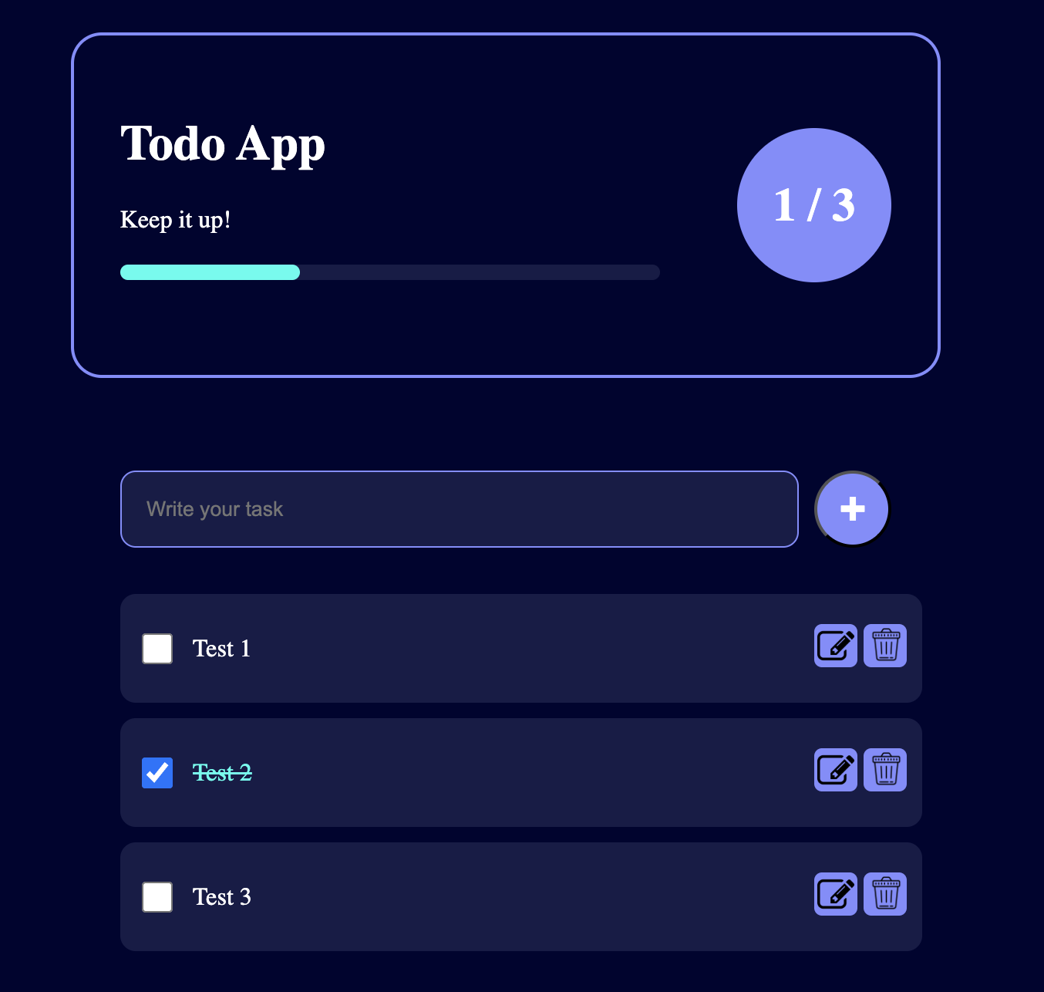
Figure 37: Progress Bar
As we look to the future development of our task management application, a key feature we plan to integrate is an enhanced task progress bar. This progress bar will dynamically respond to user interactions directly from a single, unified page, improving usability and efficiency. Users will be able to see real-time updates to their progress as they check off completed tasks, providing immediate visual feedback that reflects their achievements.
The single-page interface will be designed to allow all task interactions—such as adding, editing, and removing tasks—without the need to navigate away from the page. This approach not only streamlines the user experience but also minimises load times and simplifies the application's interface, making it more intuitive. Changes made by the user will be communicated to the server asynchronously, allowing the page to update swiftly without a full reload.
This development is expected to significantly enhance the application's functionality by making task management more seamless and visually engaging. The goal is to create a more interactive and satisfying experience for users, enabling them to manage their tasks more effectively and with greater satisfaction.

Colour Blindness
In our preliminary report, we stated that the app will be designed with consideration for individuals with colour blindness. During the studies, we discovered that lack of colour perception is a major factor present in many people across the world – a man in every 12, or a woman in every 200. The most frequent form is the red-green colorblindness. With this knowledge, the design of an appealing application is done in a way that the colour visually impaired persons can also be able to use it conveniently. Due to some delays during the development process, we have not implemented the stylings for colour blinded people in the current version and reserved this for future updates.

Based on this research, the following measures will be taken to ensure the application is accessible to users with colour blindness:

Contrast and Color Selection: We will also check for a high contrast colour palate to improve text readability especially for those who are colour blind. This will go a long way in preventing the use of certain colours to relay important information as is often witnessed.

Accessible Colour Palettes: In future designs, we will incorporate visible colours that are differentiable by the people with different types of colour blindness. Employing features including the colour blindness simulator shall assist in confirming whether the chosen colours will be appropriate for all the users.

Minimise Dependence on Colour: In this way we will make sure that no important information or any action will solely be conveyed through the use of colour. Buttons, elaborate alerts, and notifications will have text, icon or pattern related to use meaning.

Text and Labelling: It will also ensure that labels and descriptions adopted are used with a high level of consistency especially where colour forms part of the design. Such an approach will help the users with limited colour vision to be able to navigate through the app despite having Colon blindness.

Agile in practice

Task Table:
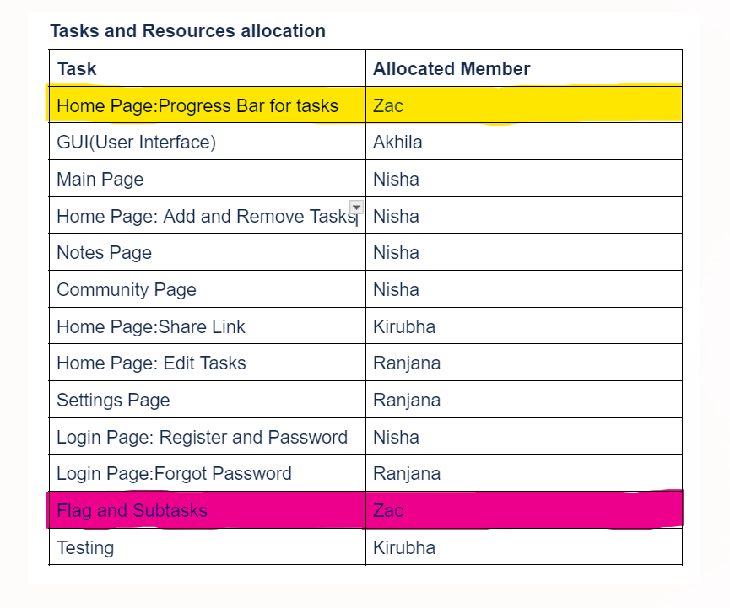
Figure 37: Final Task Table

The tasks completed are left as white. The tasks in pink have not been started yet, and the tasks in yellow have been started but not completely finished. The progress bar was made, but was not incorporated into the final project because there were some issues with the styling of the progress bar. As the webpage was styled using TailwindCSS, there were some areas where the CSS was clashing with the CSS of the progress bar.

Schedule:
The group did not end up following the planned schedule completely. There were issues where a teammate would not respond quickly or some were unavailable for quite some time, so the schedule did not go completely to plan. There were issues where some of the tasks were not finished on time as a teammate did not meet the deadline, and so those tasks were not incorporated into the final design of the website and application. Even though the schedule was not followed completely, the application was completed before the deadline.

Iteration and Feedback:
There were multiple changes made to the final design of the website and application based on user feedback. The first iteration of the website was shown to users, and they were asked to fill out a survey based on the first iteration. In general, the feedback seemed to be positive towards the first iteration, but there were a few issues for some users. Keeping those users in mind, we designed the second iteration. The second iteration had a slightly different layout and the same colour palette was used throughout the website and application to ensure that they seemed homogeneous. Another survey was sent out based on the second iteration, and users seemed to like it more than the first iteration.

Tools used:
The main tools used throughout the project were GitHub, Telegram and Discord. A group chat was made on Telegram to be able to communicate with the team, and GitHub was used so that we could share our work with one another. The Telegram group chat was also used to divide work among the team and to check whether or not their assigned tasks were finished. Discord was used to conduct meetings.

Team Collaboration:
Our team made extensive use of both Discord and Telegram to ensure that we were all well connected and communicating on the project. To keep our progress on track and aligned, we had regular meeting sessions twice a week in Discord where we reviewed the progress of an individual's tasks, discussed any issues we faced during development and planned to allocate the tasks for the following week. Prior to committing any changes to Git, we’d inform each other in Telegram group chat so that all the members are aware of the changes made and to avoid conflicts or integration problems. This practice was productive in terms of management, avoiding confusions and maintaining the integrity of the work in the overall development.

Conclusion
The task management application project successfully delivered a robust and user-friendly tool designed to enhance productivity and facilitate effective task management. This accomplishment was achieved through a combination of advanced technical solutions, strategic planning, and a user-centred design philosophy. Throughout the development process, the project team navigated numerous challenges, ranging from backend scalability and security to frontend usability and responsiveness.

On the backend, the application was built using Node.js and Express, which provided a solid foundation for handling server-side logic efficiently. The use of SQLite facilitated straightforward data management and ensured reliable transaction processing. Security was a paramount concern that was addressed through the integration of technologies like Bcrypt for password hashing.

The design approach, empowered by TailwindCSS, ensured that the application was accessible and responsive across various devices and screen sizes. The implementation of thorough user testing led to an interface that was not only visually appealing but also intuitive and accessible to users with varying levels of technical proficiency.

One of the standout features of the application was its community page, which fostered user interaction by allowing task sharing, achievement postings, and real-time feedback. This feature effectively created a supportive environment that encouraged productivity and user engagement.

This project represents a concerted effort to address the multifaceted needs of task management through a combination of thoughtful design and technical diligence. While the application achieved many of its goals, the journey was a learning experience, highlighting the importance of adaptability and user feedback in software development. The team is grateful for the opportunity to develop this tool and hopeful that it will serve its users well, providing a helpful resource in managing their tasks more effectively.

References
Basic footer - Tailwind CSS Example. (2022, November 30). TailwindFlex. Retrieved September 9, 2024, from https://tailwindflex.com/@mr-robot/basic-footer
Bcrypt Online Generator. (n.d.). Simtech AG. Retrieved September 8, 2024, from https://www.simtech-ag.ch/tools/crypt/bcrypt
chaijs/chai: BDD / TDD assertion framework for node.js and the browser that can be paired with any testing framework. (n.d.). GitHub. Retrieved September 8, 2024, from https://github.com/chaijs/chai
Download SQLite Logo Vector EPS, SVG, PDF, Ai, CDR, and PNG Free, size 375.32 KB. (n.d.). CDNLogo. Retrieved September 8, 2024, from https://cdnlogo.com/logo/sqlite_41572.html
guide, s. (2024, August 1). The Ultimate Guide to Tailwind CSS and its Best Practices. Benjamin Crozat. Retrieved September 8, 2024, from https://benjamincrozat.com/tailwind-css
HSK Study and Exam — SuperTest old version. (n.d.). HSK Study and Exam — SuperTest. Retrieved September 8, 2024, from https://hskonline.en.aptoide.com/versions
Nash, P. (2019, January 10). How to start a Node.js project. Phil Nash. Retrieved September 8, 2024, from https://philna.sh/blog/2019/01/10/how-to-start-a-node-js-project/
Owolabi, B. (2023, August 1). Introducing Rapid-Xpress: A Lightning-Fast Scaffolding Tool for Express.js Applications. Level Up Coding. Retrieved September 8, 2024, from https://levelup.gitconnected.com/introducing-rapid-xpress-a-lightning-fast-scaffolding-tool-for-express-js-applications-210a5cbf0274
ruanyf/mocha-demos: a collection of simple demos of Mocha. (n.d.). GitHub. Retrieved September 8, 2024, from https://github.com/ruanyf/mocha-demos
Tailwind CSS Form Layouts - Official Tailwind UI Components. (n.d.). Tailwind UI. Retrieved September 8, 2024, from https://tailwindui.com/components/application-ui/forms/form-layouts
Tailwind CSS Sign-in and Registration - Official Tailwind UI Components. (n.d.). Tailwind UI. Retrieved September 9, 2024, from https://tailwindui.com/components/application-ui/forms/sign-in-forms
Tailwind: how to fit image inside navbar parent div. (2021, April 10). stack overflow. https://stackoverflow.com/questions/67030315/tailwind-how-to-fit-image-inside-navbar-parent-div
TW Elements integration with Express - Free Examples & Tutorial. (n.d.). TW Elements. Retrieved September 9, 2024, from https://tw-elements.com/docs/standard/integrations/express-integration/
Using TailwindCSS with Express and EJS. (2022, October 4). DEV Community. Retrieved September 9, 2024, from https://dev.to/covalhalla/using-tailwindcss-with-express-and-ejs-2hl0

Appendices

Appendix A:
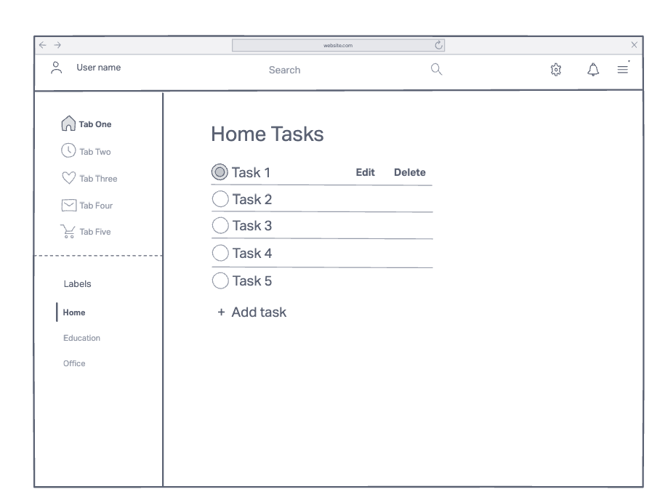
(a)Home page
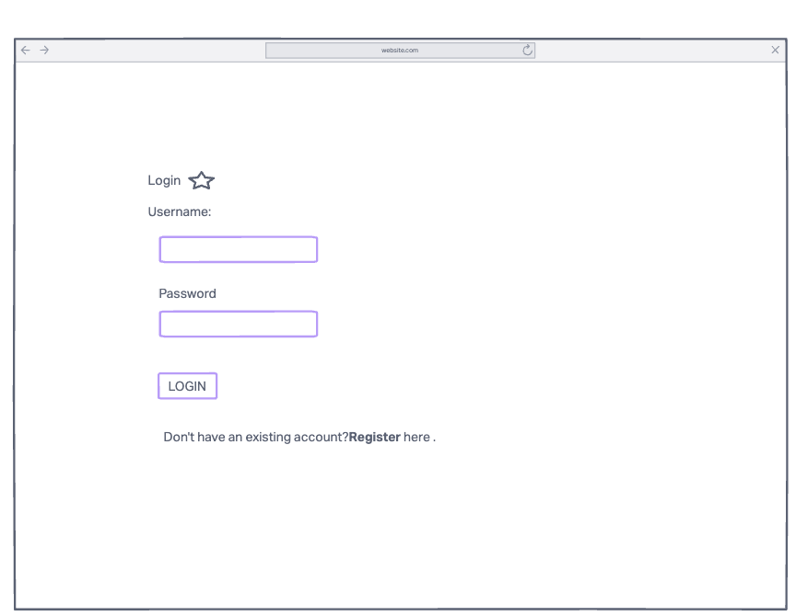
(b)login

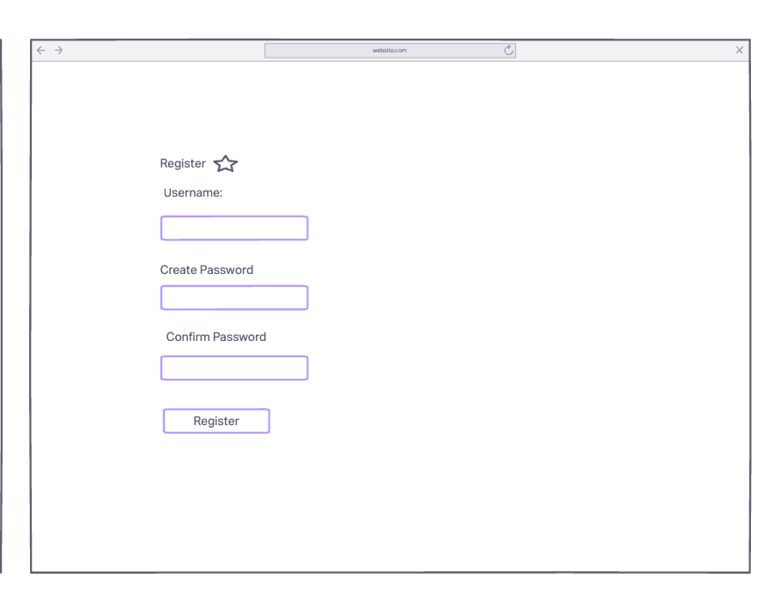
(c)register
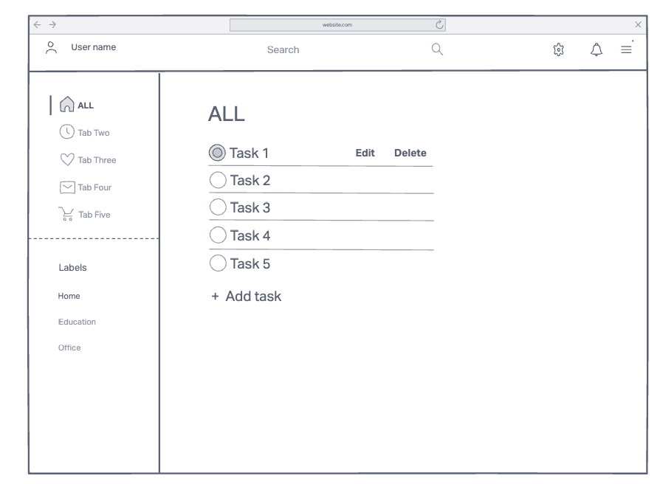
(d)edit task
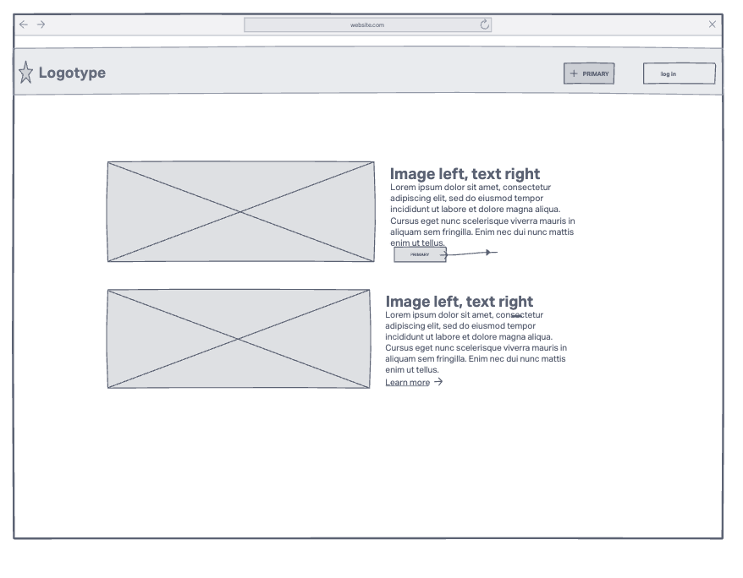
(e) introduction page
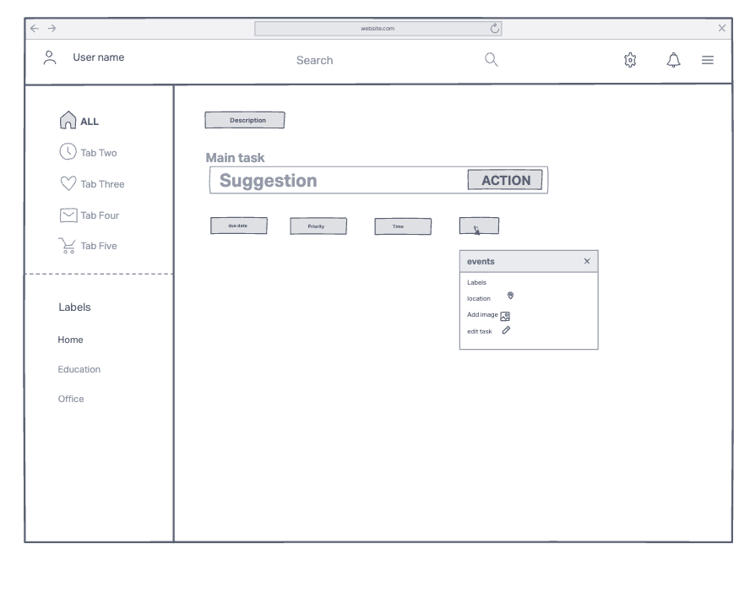(f)add task

Appendix B:

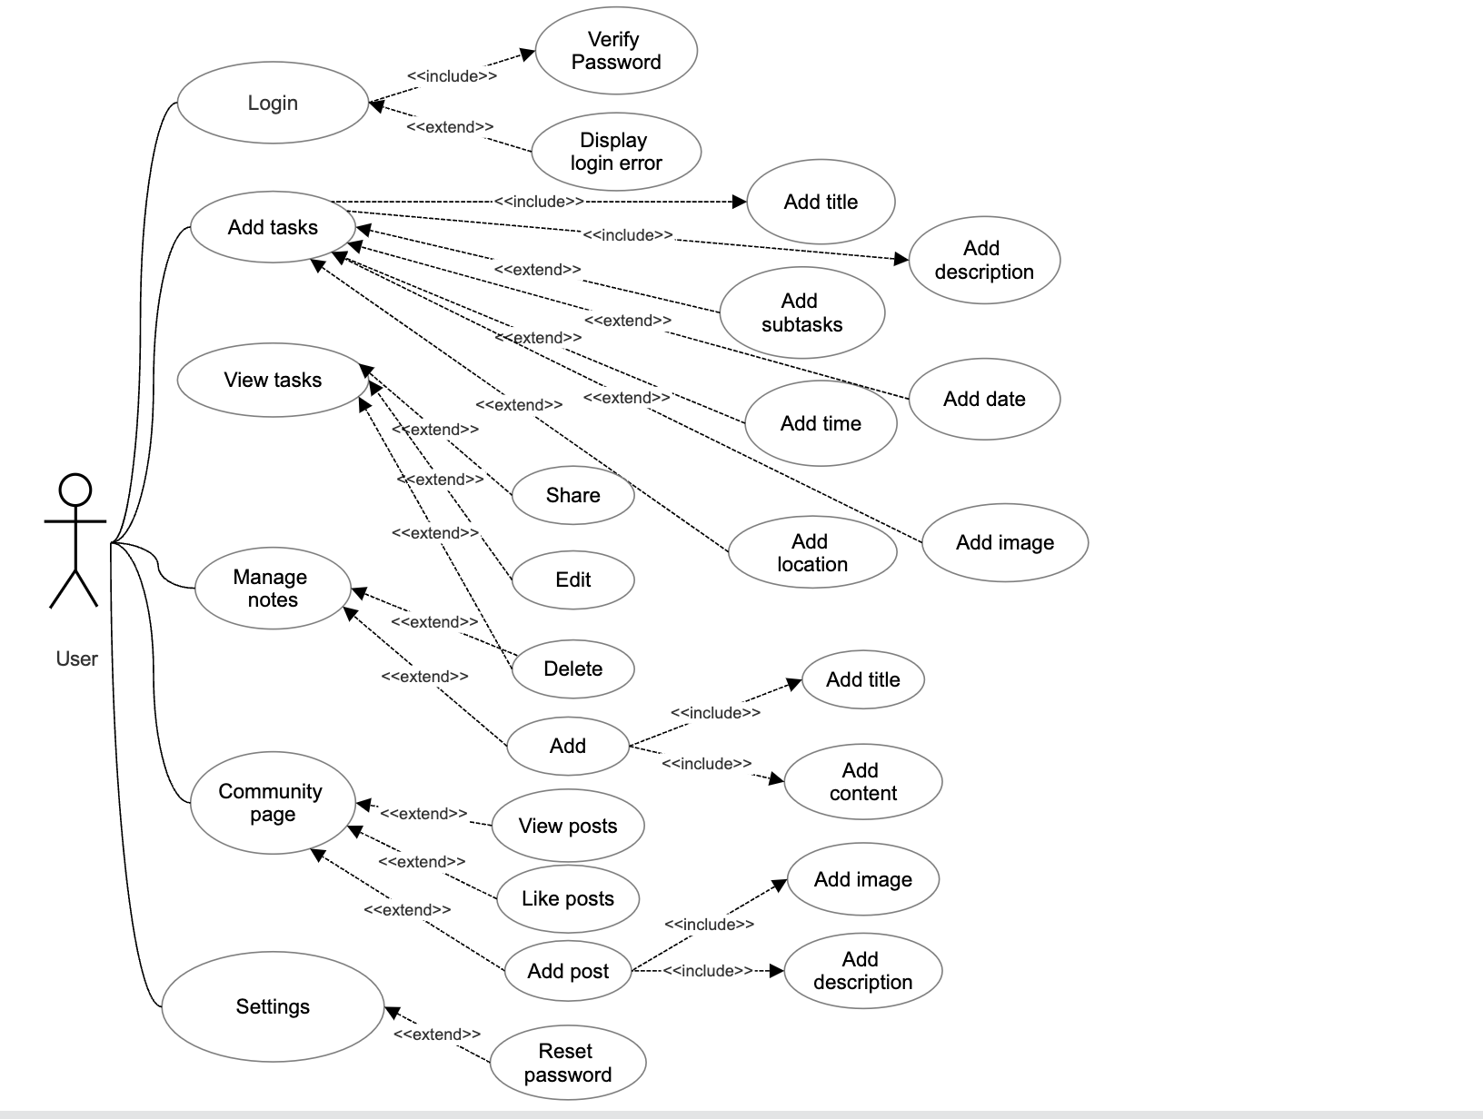
- Use Case Diagram

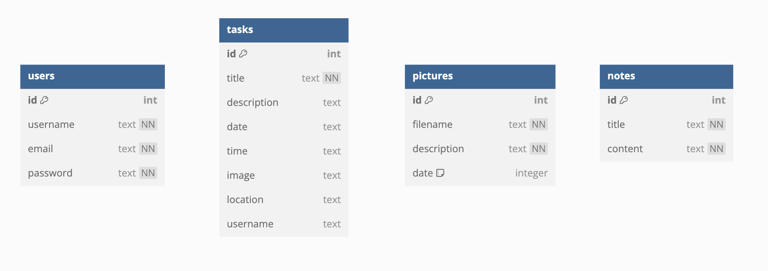
- Entity Relationship (ER) diagram

(Owolabi, 2023)
(Nash, 2019)
(Download SQLite Logo Vector EPS, SVG, PDF, Ai, CDR, and PNG Free, Size 375.32 KB, n.d.)
(guide, 2024)
(Bcrypt Online Generator, n.d.)
(Ruanyf/mocha-Demos: A Collection of Simple Demos of Mocha, n.d.)
(Chaijs/chai: BDD / TDD Assertion Framework for Node.js and the Browser That Can Be Paired With Any Testing Framework., n.d.)
(HSK Study and Exam — SuperTest Old Version, n.d.)
(TW Elements Integration With Express - Free Examples & Tutorial, n.d.)

